WallboxPlayer – Packard (24lines)
www.wallboxplayer.com
Sep 2025
This WallboxPlayer is a device that turns your wallbox into a music player. This manual provides basic instructions on how to install and operate the WallboxPlayer.
WallboxPlayer Features
- Have your wallbox play your favorite music with or without a jukebox
- Song queue and/or random play
- Audio (3.5mm jack) and 2 speaker outputs

General Description
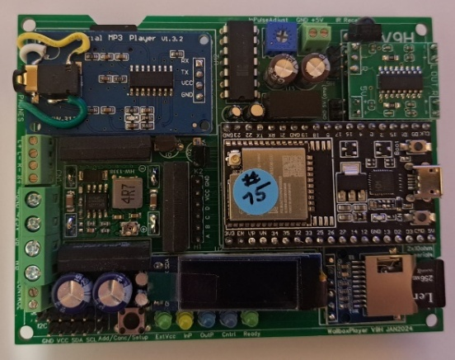
The WallboxPlayer supports a range of pulse-controlled jukeboxes. Tuning and customization is possible. Power to the player is provided from the wallbox, reducing the need for an extra power supply. Music is stored on a microSD card and can be filled matching the wallbox titles.
The WallboxPlayer board has connectors for most of the connections to be made to wallbox, and speakers. The on-board MP3 player accepts a user-filled microSD card. It has a jack plug for external audio. The board has an optional data microSD slot for supporting functions. There are buttons for HW reset on the microprocessor and ‘Select’ to do the setup, cancel or add a play. Optionally, the board features header connectors for an external 16x2 I2C LCD display. All settings are done in the setup through software and stored. The board can be powered through the external 24VAC and converts this to 5V through the on-board voltage converter. The board is 7.5 cm x 9 cm and can be mounted outside in a separate housing.
WallboxPlayer with top cover
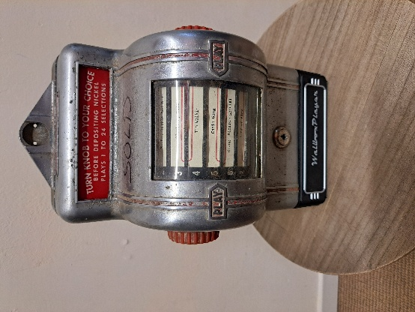
The Packard does not require 24V but only has lamps. Power to the board must be 5V -or- 8-24VAC or DC (through onboard buck converter).
The MP3 SD card slot can be found on the top left under the MP3 player; contacts should be on your side and visible before inserting. The MP3 files are stored on a micro-SD card. Ensure the card is clicked in. The microSD card must be formatted as FAT32 (max 16GB), The number of (.MP3) files can be as many selections as the wallbox can select. The best place for the MP3 files is in the root folder of the card. When copying files from the PC onto the SD card, windows will hustle the order that then does not match the file/selections. A foolproof way to get the numbering and order right is as follows:
- Format the SD card
- Copy files from computer to SD with drag and drop, one at a time starting with the first one
- Wait until each file is copied, then copy the next (every time just one at a time)
There is a second microSD (FAT32) slot for configuration settings and songname information. Refer to the full manual for details. When during startup, the MP3 files cannot be read, the status LED will blink twice, and the red MP3 player LED will not be on.

Speaker output is via the (optional) onboard amplifier, two speakers (max 2*3W) can be connected. These speakers can be within the wallbox or external. The speaker output is via the connector labeled SpL+ SpL-, SpR+ and SpR-. Note the difference for wiring two separate speakers or a 3-lead consolette (see further below in this doc)!

LEDs onboard are used to display status:
- ExtVcc [green] Lights when an external 24V is connected (converted to 5V), supplying the board
- InP [yellow] – lights up when a wallbox pulse is detected
- Cntrl [blue] – option, indicates enabling the control relay e.g. for ‘make selection’ lightbulb
- Ready [green] – shows that system is listening/ready to accept inputs (from wallbox or app).
The MP3 player mounted on the board has a red light that lights when the player is ready and blinks when playing a song. The microprocessor mounted on the board has an onboard red light that is on when the system is ready.

Installation
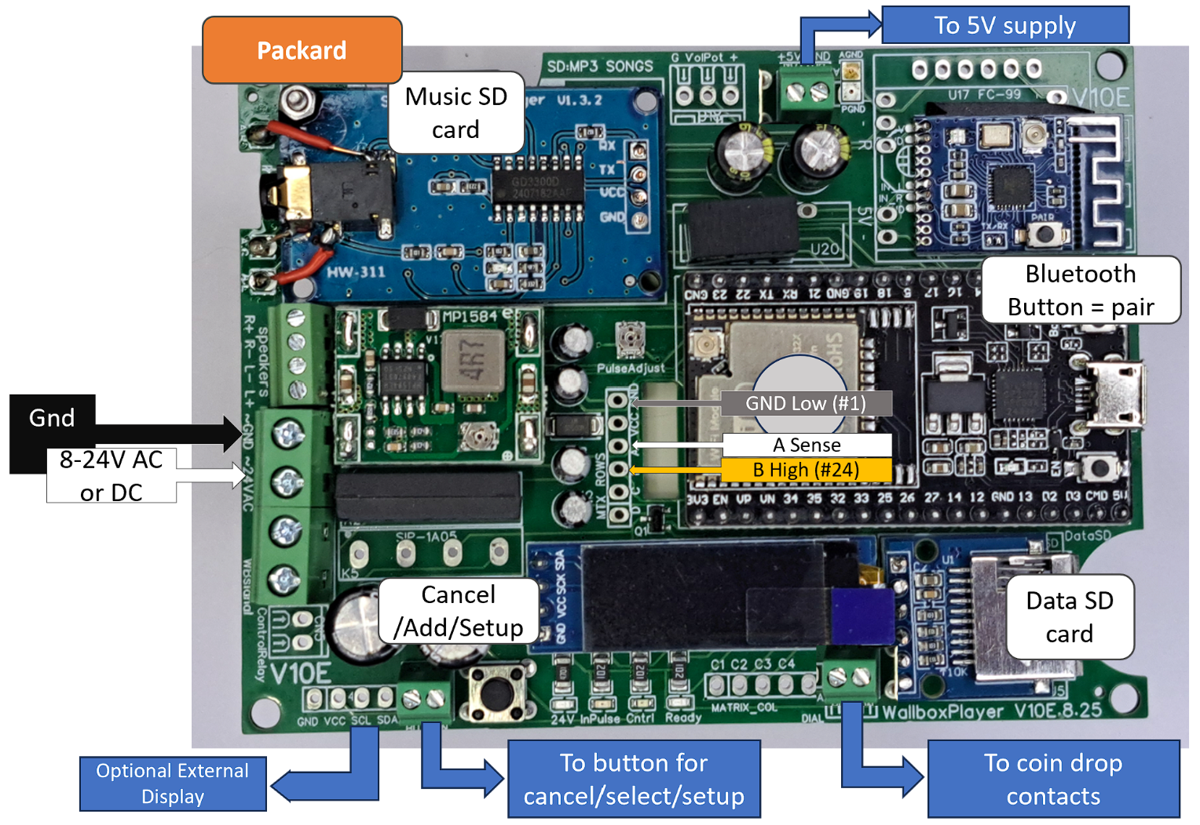
Connectors on the WallboxPlayer board:

Overview of wiring to wallbox (Packard):
The board can be connected to 8-24VAC or DC or a 5V (note polarity; not 7.5V quickcharge USB chargers!). The 5V green connector is NOT an output. It is to supply the board.
After connections have been made, powering up should show screen startup messages with release version, jukebox and wallbox type (including number of selections), operating mode and number of MP3 files on card. After a few seconds the system will show the green status light and be available for selections and will display ‘Select Song’. When during startup, the MP3 files cannot be read, the status LED will blink twice, and the red MP3 player LED will not be on.

INSTALLATION:
The kit recreates the original operating conditions of your Wallbox PACKARD PLA-MOR and BUCKLEY wallbox.
The installation can be done in 2-3 hours. Put your favorite songs on the microSD card, even more than 24 (for AutoPlay). The selections will be issued as original by turning the wallbox knob to align the label on the side arrows. The music will start after introducing a coin of 5 cents (nickel).

Diagrams overview:

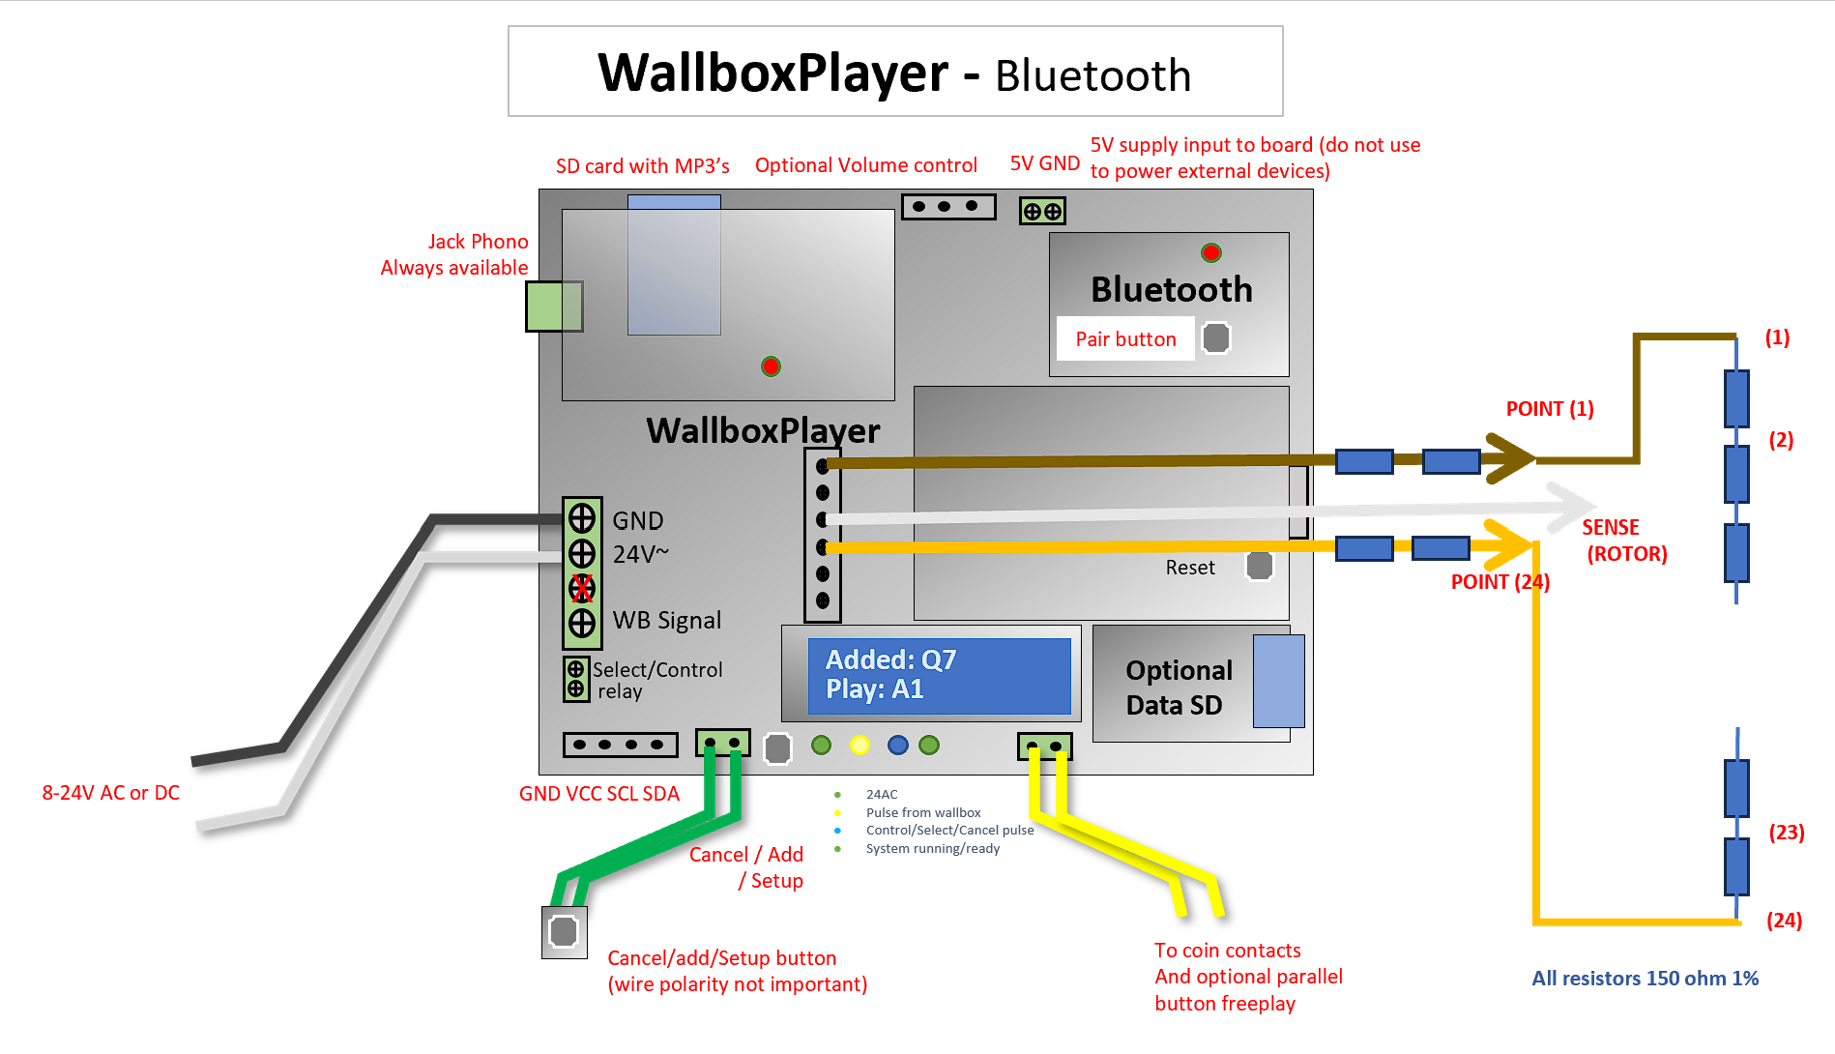

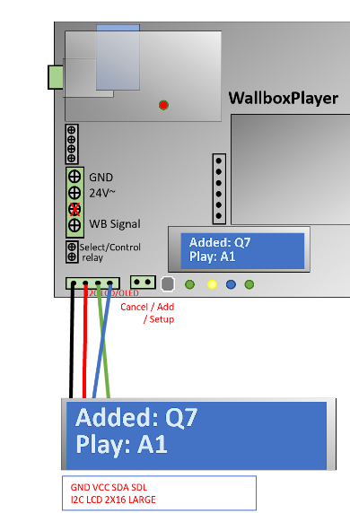
Before performing the installation, you must ensure that the wallbox is fully operational, and the coin unit must accept coins to start music. The various contacts of the internal wheel, and the coin passage in the coin mechanism must be previously cleaned. Clean the Packard and contacts before use. The set will be stripped of its former potential wiring. To facilitate assembly, temporarily remove the red knob, the lateral support, and the power cable connected to the terminal near the axis of rotation of the left side of the wallbox.

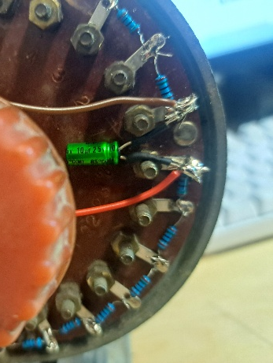
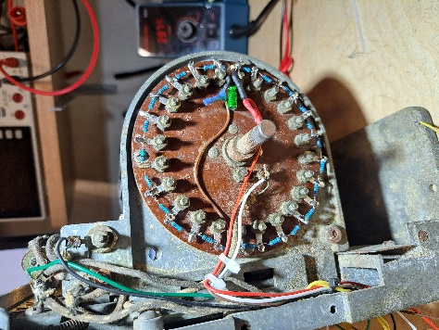
Two double resistors are in the brown and red wire. If these are in the wires, the brown and red can be soldered directly to (1) and (24). Assemble the 23 resistors (between 1-2 2-3 2-4 …. 22-23 23-24) with the solder joints and connect brown to (1) and red to (24). Resistors (high accuracy 1%) have no polarity and there is no order. Mount the bipolar capacitor between brown and red for voltage stability.

The result should be as picture. Strongly tighten the nuts and clean contacts and wiper.
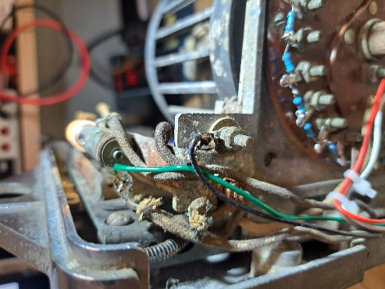
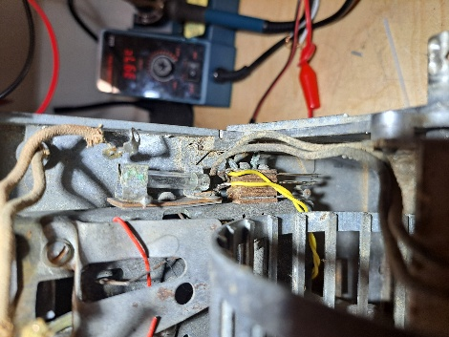
Connect the 2-wire coin flipper contacts (yellow on picture - solder onto connection strips). You should now have 5 wires going out that are connected to the WallboxPlayer.

Connect the lamps to a 5 or 6V power supply (green and black as shown on picture). If this is the same 5V as the WallboxPlayer, ensure it provides enough power/current.

Replace the side support and the red knob, the wallbox is ready for operation.

Mounting the WallboxPlayer and button OUTSIDE the wallbox and making connections
- Mount the board in the external housing
- Mount the select/cancel/setup button in one of the holes and connect the select/cancel/setup button on the board next to the button, polarity/wire order or is not important)
- If there is an optional external display, connect the 4 wires as shown on the photo.
- The three wires from the Wallbox round plate and the 2 wires from the coin flipper must be properly connected to the WallboxPlayer (see connection diagram)
- There are two options to connect the 24V AC adapter onto the Wallbox -OR- onto the WallboxPlayer to power both devices. Not both! The 5V on the green screw connector is NOT an output, do not connect to drive the lamps, you will burn the board. See below.

Connecting the speakers (for versions with an onboard amplifier)
Important: Connecting the speakers in a wallbox (or a set of 2 speakers)
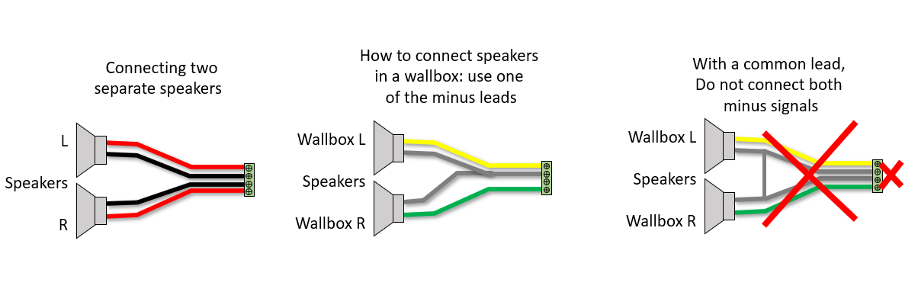

Note1: the built in stereo audio amplifier of the WallboxPlayer is a Class D. This means that it
has floating outputs. You must never connect the two minus ( - ) together, each one must be wired to
its own terminal. Or you could just destroy the built-in audio amplifier. Please just connect your speakers with one of the correct wiring options above.

Note2: connecting one or more of the 4 leads to the wallbox chassis ground can cause irreparable damage to the board and amplifier.

Connecting power to the WallboxPlayer and powering up
- After powering up, the WallboxPlayer will also power up, and the display will show relevant information on status and number of songs etc. After starting up, “Select Song” will show.
- Press the “Select/Cancel/Setup button on the board to test if song will start. Press again to cancel.
- Make selection on the wallbox and drop a coin or press the ‘activate’ button. Song will start and number played will be shown.

Adjustments
- In setup mode, set “Wallbox_in” to Packard. Restart the player and now go to change the specific settings for the resistor-network. “Resistors_Offset” (default 90) and “Resistors_Divider" (default 140). These will determine how resistor/voltage is translated into a selected number.
- Now check the response of each of the knob settings (1…24) with in the setup “LISTEN” mode. Ideally with these two settings, values are 0.5 more than the selected number. E.g.: 1.5 for 1, 2.5 for 2, 3.5 for 3, …, 23.5 for 23, 24.5 for 24. They can range from +0.2 to +0.8 but should not be too close to 0.1 and 0.9 as then there is a risk that values over- or under-run.
- Resistors_Offset will shift all the numbers higher (if increased) or lower (if decreased).
- Resistors_Divider if increased will bring the numbers closer together, or if decreased further apart.
- To calibrate/get a start position record ADC values for (1) and (24):
  - Resistors_Divider = (ADC(24) – ADC(1) )/23. E.g. (3368-148)/23 = 140; Note that small changes e.g. 139 or 141 can have a big impact.
  - Resistors_Offset = ADC(1)/2. E.g. 148/2 = 72. As each step is approximately 140, a value of e.g. 14 will shift everything up or down with 0.1 (1 decimal).
  - Now fill these values in and see if all setting numbers are correct and all decimals fall into the range of 0.2 to 0.8 for best reliability.
  - If incorrect, tune these two values taking into account the effect they have. Note that numbers below 2 always will be translated into (1) and numbers above 23 always into (24).
  - If you really see a very nonlinear response going from 1 to 24, check the resistors or contact.

Pairing optional Bluetooth (option)
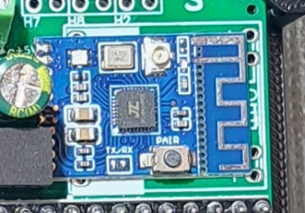
- When paired and connected, the red BT board LED blinks twice at ~5 sec interval.
- When idle and unpaired the red led flashes slowly (~1sec interval)
- Short press the button for unpairing.
- To pair with a Bluetooth device, ensure it is not paired (with other device) now, put the Bluetooth speaker in pairing mode and press (2sec) the pair button, the red led will blink slowly (at ~2sec interval) and start pairing
- For more information look at the KCX BT module documentation.

Setup
The onboard ‘select’ button to perform setup serves two functions, its primary function is to cancel the currently playing song or add a song when nothing is playing. The secondary function of this button is used within the setup menu which follows. The setup menu is accessed by pressing the ‘select’ button for 5 seconds. After the instruction, which will be displayed for a few seconds, subsequent settings will be shown to be modified. Pressing the button will change the value of the item, waiting will show the next configuration item.

The setup menu allows you to configure the following settings:
- Tools: This menu choice will allow system updates, reset values, restart and a measure/listen utility mode. “RESTART” will restart the device. Note that the MP3-player will keep playing until early in the startup process. Selecting “DEFAULTS” will set values of settings back to factory defaults. Choices: NO, RESTART, DEFAULTS, UPDATEMODE, LISTEN, …
- Wallbox In: This will configure what input signal is detected by the board, the type of wallbox the board is connected to. Compatible choices: NONE, MP3, Sb_3W1, Sb_3W100, Sb_3W160, Sb_3WA, Sb_3W1_A1B1, Sb_3W1_AltFix, Sb_SC1, Sb_DEC, Sb_DEC-direct, Ami_W40, Ami_W80, Ami_W120, Ami_W200, Roc_1544, Roc_1555, Roc_1558, Wur_5207, Wur_5210, Wur_5220, Wur_5225, Packard, and others…
- Jukebox Out: for WallboxPlayer mode and audio output, this must be MP3. For other selections, it will send out a pulse to a connected jukebox.
- Resistor_Offset will shift all the numbers higher (if increased) or lower (if decreased).
- Resistor_Divider if increased will bring the numbers closer together, or if decreased further apart.
- AutoPlay: This value sets the time in seconds until a random song is added to the queue. Selecting 0 will disable this function. Setting it to 60 will add song after one idle minute. Choices: 0, 15, 60, 300, 3600.
- Volume: This will determine the output volume of the MP3 player (jack output and speakers). It can be adjusted from 0 to 24. Choices: 0…24.
- Equalizer: This will select one of the available equalizers (jack output and speakers). Choices: FLAT, POP, ROCK, CLASSIC, BASS and BOOST modes (+20%). Suggested are Pop or Bass.
- AutoPlay_number: If selecting this number with the buttons, (1=A1 etc.) autoplay starts and plays random songs until selected again. (0, 1 … 159, 160, 200 (default is 0). Suggested is 1, first selection.
- Control_mode: Option. This determines the function of the additional on-board relay: NONE, JBCANCEL, WBCOIN, WBCREDIT, SELECT, … The “Select mode” can be used to enable the “Make selection” lightbulb in the wallbox.

OPERATION:
After power up, it takes 6-8 seconds for the player to be ready. The WallboxPlayer in the wallbox (or an enclosure) has the following functions available:
- Press the “Select/Cancel/Setup” button on the board or the connected button mounted in the wallbox to start a (random) song. Press again to cancel.
- Make selection on the Wallbox (and drop the coin to activate). The selected song will start.
- Songs can be selected on the wallbox, play will start after selection or when a song is playing, song will be added to the queue (up to twenty songs in a queue).
- If a song is playing, the ‘select’ button will cancel the song (and play next in queue)
- If no song is playing, pressing this button will add a random song to the queue.
- AutoPlay: Pressing the select button longer (1-2sec) will start and stop AutoPlay. Random songs will automatically be added and played (even MP3’s on the SD beyond the selection limit – see further below), press button 2 seconds again to switch off the function.
- If enabled, AutoPlay can also be started and stopped with wallbox buttons defined by the AutoPlay number in the setup.
- For the AlbumPlay mode, selections will play folder /XX/ and extra songs in folder /99/. When playing, short-press will skip to next song, long-press will cancel current album-play.
- Dial and Keypad players: 00/000 is “AutoPlay”; 99 or 999 can be set up as “Play favorites” with a button to add a playing
- WallboxPlayer may have an optional external volume control (50k 3-wire) to control sound from 0-100%.

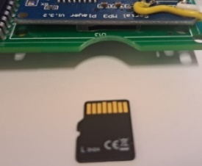
SONGS ORDER. (Re)loading songs, playing more than selectable, and making listing:
The MP3 (or WAV, WMA) files are stored on a micro-SD card. Ensure the card is clicked in. The microSD card MUST first be formatted as FAT32 (max 16GB as some 32GB cards cannot be read).
There are 3 different selection modes. Versions up to SW V14 only have FilePlay (default).
* SelectMode = FilePlay (Default)
Place selectable files in the card root folder (filename is not important/relevant). Note when copying files from the PC onto the SD card, Windows hustles the order that then does not match the file/selections. On Apple-Mac, specifically select the order you want (e.g., alphabetical). To get the ordering right is as follows:
Format the SD card; Copy files from computer to SD, one at a time starting with the first one; Wait until each file is copied, then copy the next (every time just one at a time).
This way, windows will not change the order as every file can only be added and has a later timestamp than the previous one.
* SelectMode = MP3NumberPlay (SW V14 and up)
This mode allows ordering by filename numbering and is easier for individual replacements. Files must be placed in folder /MP3/ and numbered using 4 digits 0001.mp3, 0002.mp3, 0003.mp3 etc. Note: if using a four-digit number and space followed by a filename ‘0001 my way.mp3’, files will play correctly but not labeled by SD2.
* SelectMode = AlbumFolderPlay (SW V14 and up)
A complete album/LP can be played with one selection. Cancel plays next album song. A set of files (album songs) should be placed in folders /01/, /02/, /03/, etc. /99/ is for extra songs 001.mp3, 002.mp3.
Note: to list the order of the songs on the music SD, use DOS command (run CMD after clicking search icon and CD to your SD card): then DIR /B /A:-D *.MP3 > SONGS.TXT. This will create a file that you can read and use for song titles
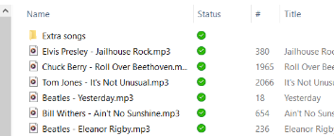
The WallboxPlayer can play songs that go beyond the selectable numbers through AutoPlay (random). Either create an extra folder (after having put the selectable songs in the root music SD) e.g., /Extra/ and simply fill it with the songs you want to hear in random play mode -or- add more songs in the root than can be selected.
CREATE SONGTITLES: The following free web-applications to create strips are available: https://www.pinballrebel.com/archive/other/onlinenew/index.html or https://www.mikesarcade.com/arcade/titlestrips.php .
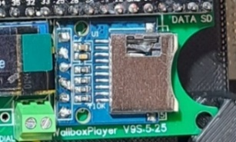
WallboxPlayers with data SD slot option: Configurations that have a data SD card (right of the display, see picture), enable creation and use of song labels and displays song filenames. For labels and the display, song information from the MP3-ID3 tags (software >V14.5) are retrieved, or otherwise filename (“Artist - Song”), will be generated. Once this is done, the data SD card can be removed (returned into the player slot) and songtitles are remembered.
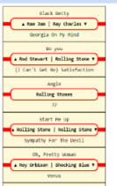
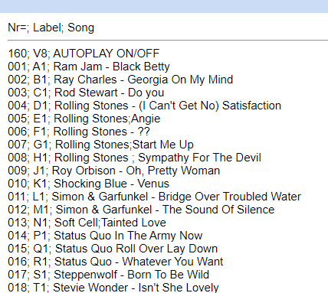
- To generate these files, insert the MUSIC SD (with MP3’s) in the data SD slot and (re)start the device. Files SONGS.TXT, PRINT.HTML and LABELS.HTML are generated in folder /labels/. These can be used to help make song listings and labels (open with computer). Files can be edited/corrected by clicking and editing before printing. After generating files, insert music SD into the blue player SD slot again.
- To generate a custom listing or for album mode play, the file SONGS.TXT (with a song- or album-name on each line, sequential) on the data SD card in /labels/ (/labels/SONGS.TXT) will determine the labels shown on the display.

Please contact me in case of questions or inquiries or items not described here.
Joop van den Heuvel
Sint-Oedenrode, The Netherlands
jhmheuvel1@gmail.com and Joopheuvel on Jukebox Addicts Board

Pictures: 3W1, 3W160, 3WA.

