WallboxPlayer – Wurlitzer
www.wallboxplayer.com
Sep 2025
This WallboxPlayer is a device that turns your wallbox into a music player. This manual provides basic instructions on how to install WallboxPlayer. Refer to the users manual on how to operate and use.
WallboxPlayer Features
- Have your wallbox play your favorite music without a jukebox
- Song queue and/or random play
- Audio (3.5mm jack). Bluetooth or two speaker outputs

General Description
The WallboxPlayer supports a range of pulse-controlled jukeboxes. Tuning and customization is possible. Power to the player is provided from the wallbox, reducing the need for an extra power supply. Music is stored on a microSD card and can be filled matching the wallbox titles.
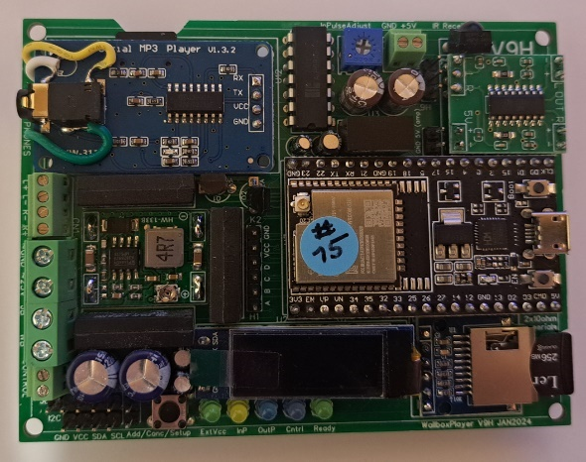
The WallboxPlayer board has connectors for most of the connections to be made to wallbox. The on-board MP3 player accepts a user-filled microSD card. It has a jack plug for external audio. The board has an optional data microSD slot for supporting functions. There are buttons for HW reset on the microprocessor and ‘Select’ to do the setup, cancel or add a play. LEDs indicate pulses coming in. Optionally, The board features header connectors for an external 16x2 I2C LCD display. All settings are done in the setup through software and stored. It has one trimmer to tune the sensitivity/speed of the incoming pulse signal. The board is powered through the external 24VAC. The board is 7.5 cm x 9 cm and can be mounted in popular wallboxes, or outside in separate housing.
WallboxPlayer with top cover
The 24VAC power from the wallbox is used, either through the jukebox or a separate widely available 24VAC (48VA; 2A) transformer or adapter.
The MP3 SD card slot can be found on the top left under the MP3 player; contacts should be on your side and visible before inserting. The MP3 files are stored on a micro-SD card. Ensure the card is clicked in. The microSD card must be formatted as FAT32 (max 16GB). The number of (.MP3) files can be as many selections as the wallbox can select. The best place for the MP3 files is in the root folder of the card. When copying files from the PC onto the SD card, windows can hustle the order that then does not match the file/selections. A foolproof way to get the numbering and order right is as follows:
- Format the SD card
- Copy files from computer to SD with drag and drop, one at a time starting with the first one
- Wait until each file is copied, then copy the next (every time just one at a time)
This way, windows will not change the order as every file can only be added and has a later timestamp than the previous one. There is a second microSD (FAT32) slot for configuration settings and songname information. Refer to the full manual for details. When during startup, the MP3 files cannot be read, the status LED will blink twice, and the red MP3 player LED will not be on. To get a matching listing of the order of the songs on the SD, use WINDOWS CMD command: DIR /B /A:-D *.MP3 > SONGS.TXT
For versions with the 2x3W amplifier, speaker output is via the (optional) onboard amplifier, two small speakers can be connected. These speakers can be within the wallbox or external. The speaker output is via the connector labeled SpL+ SpL-, SpR+ and SpR-.

LEDs onboard are used to display status:
- ExtVcc [green] Lights when an external 24V is connected (converted to 5V), supplying the board
- InP [yellow] – lights up when a wallbox pulse is detected
- Cntrl [blue] – indicates enabling ‘make selection’ lightbulb
- Ready [green] – shows that system is listening/ready to accept inputs (from wallbox or app).
The MP3 player mounted on the board has a red light that lights when the player is ready and blinks when playing a song. The microprocessor mounted on the board has an onboard red light that is on when the system is ready.

Adjustments are not required. In case of issues the (blue or small smd, depending on board version) potentiometer can be used to tune the sensitivity of the input pulse from the wallbox, detected by the system. It allows for either slower turning motors or 60Hz to work properly.

BOARD AND CONNECTIONS
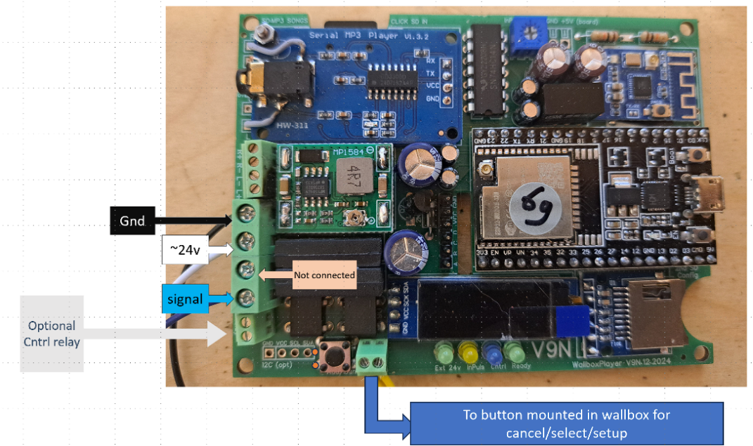
Connectors on the WallboxPlayer board:

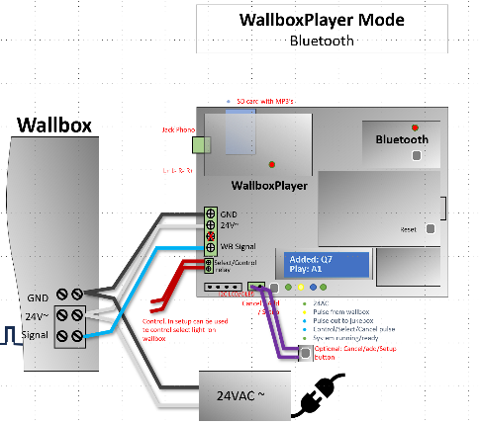
Overview of wiring to wallbox (jack and/or Bluetooth):
After connections have been made, powering up should show screen startup messages with release version. After a few seconds the system will show the green status light and be available for selections and will display ‘Select song’. If the control relay is set up to enable the lightbulb, the blue led will also be on. When during startup, the MP3 files cannot be read, the status LED will blink twice, and the red MP3 player LED will not be on. If uncoupled, the Bluetooth LED will blink slowly. When connected it will blink every 5 seconds.

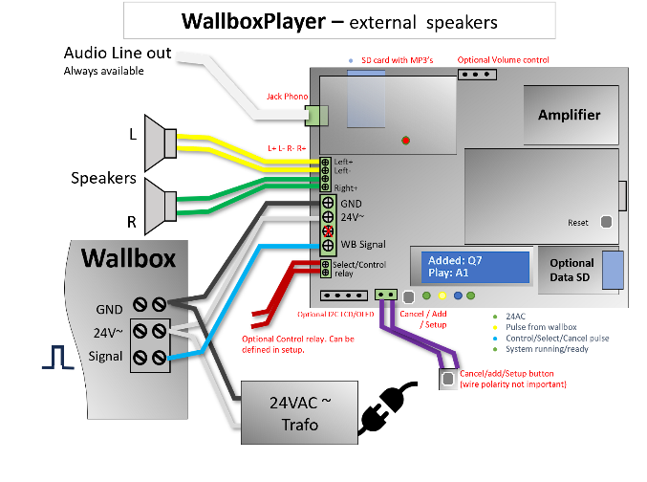
In case of a WallboxPlayer version with an onboard amplifier, use connection as shown.

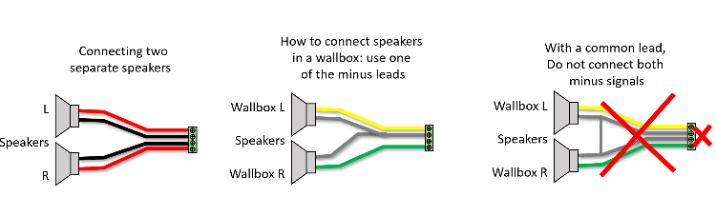

INSTALLATION:
The best place is replacing the coin unit with the black coin unit housing (remove pins that are not needed).

Prepare to mount the board
- Remove coin unit
- Remove any old cables that may have been cut
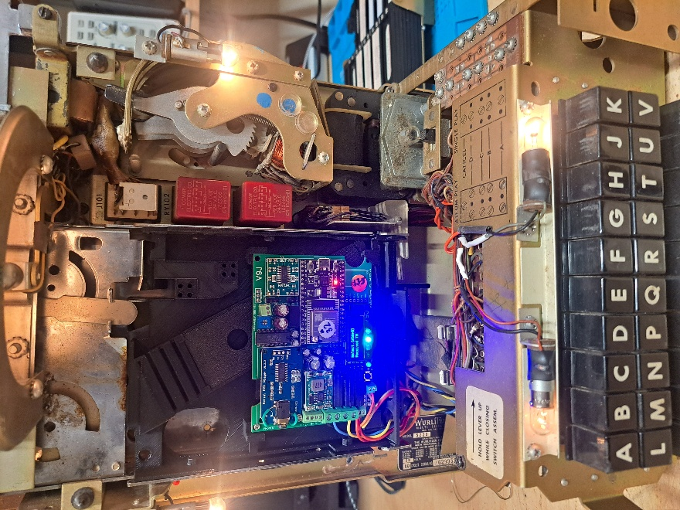
- Mount the select/cancel/setup button in a (drilled) hole on the back or bottom
- Mount the WallboxPlayer unit (with coin slide housing) in the wallbox.
- Connect the three wires to the WallboxPlayer (black = ground; white = 24V; blue = wallbox signal). (Large middle screw connector, only 3 of 4p will be used.

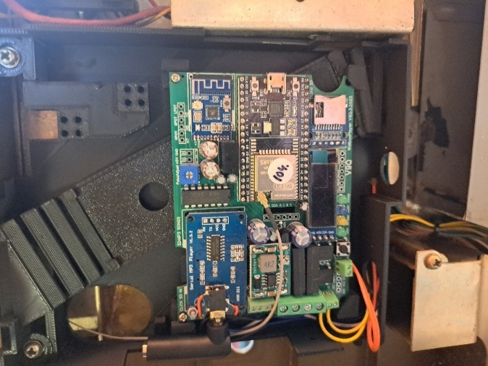
- Enabling Freeplay can be done by mechanically by strapping the pin on the credit unit (later models Wurlitzer) or bridging the coin drop contact step (earlier models).
- Connect the external select/cancel/setup button (green 2p connector next to the button) - this will allow cancel and adding random songs. See picture below.
- If available on the board (option), connect the control relay to enable the Wallbox “Make selection” lightbulb. Yellow wires (bottom 2p small screw connector). This optional control relay can be used to enable the lamp that lights up to select a song once the player is ready. See picture below.

- The wallbox now needs to be powered by 24V on the black and white connector slugs by the transformer connected to GND and 24V.
- Connect the 2 power leads (BLK and WHT) and the signal lead (BLU) from WallboxPlayer to your wallbox. 24/25VAC=WHITE; COMMON/G=BLACK. SIGNAL=BLUE. See pictures below. For some wurlitzers the contacts are under the buttonboard that has to be turned away.
- Connect the 24VAC (2A) transformer to connector BLK (=gnd) and WHT (the top two screws – see pic) on top of leads already in place.

- Wurlitzer 5220/5225:
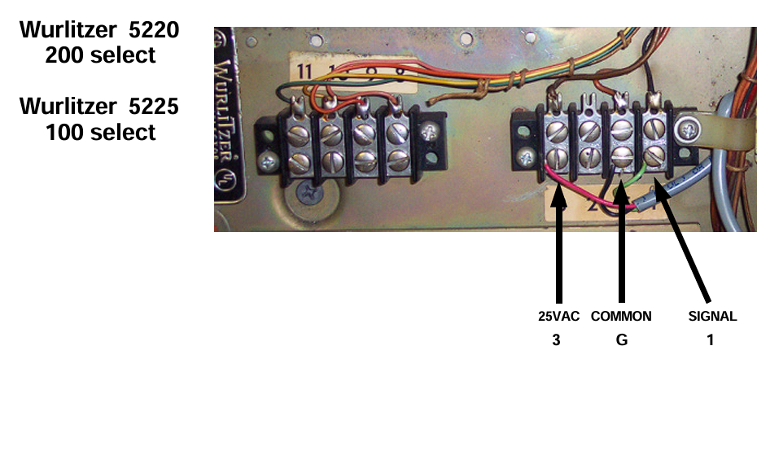
- Wurlitzer 5207 (104):
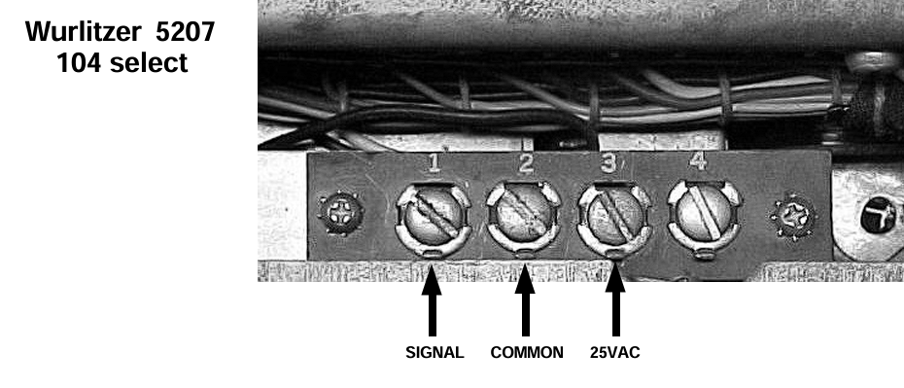
- Wurlitzer 5250 (200):
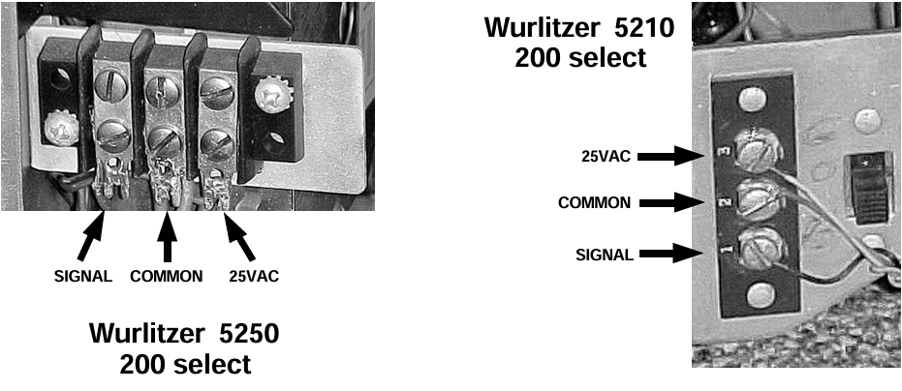
If connections on your wallbox are not listed or different, please refer to the original manuals.
- After powering up, the WallboxPlayer will also power up, and the display will show relevant information on status and number of songs etc. After starting up, “Select Song” will show.
- Press the “Select/Cancel/Setup button on the board or external, to test if song will start. Press again to cancel.
- Make selection on the Wallbox with the buttons. If blue signal lead is correctly connected, the yellow lamp will flash during rotor movement and pulses are counted. Song will start and number played will be shown.

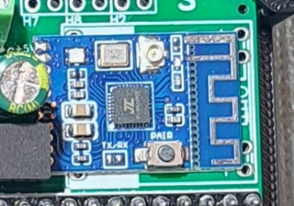
Pairing optional Bluetooth
- When paired and connected, the red BT board LED blinks twice at ~5 sec interval.
- When idle and unpaired the red led flashes slowly (~1sec interval)
- Short press the small button for unpairing. See picture.
- To pair with a Bluetooth device, ensure it is not paired (with other device) now, put the Bluetooth speaker in pairing mode and press (2sec) the pair button, the red led will blink slowly (at ~2sec interval) and start pairing.
- For more information look at the KCX BT module documentation.

Notes Wurlitzer Title strip holder
- To avoid the titleholder touching the WallboxPlayer/mount, put two spacers onto the frame (see below)
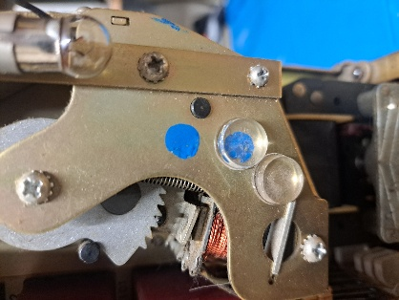

Setup
The onboard ‘select’ button to perform setup serves two functions, its primary function is to cancel the currently playing song or add a song when nothing is playing. The secondary function of this button is used within the setup menu which follows. The setup menu is accessed by pressing the ‘select’ button for 5 seconds. After the instruction, which will be displayed for a few seconds, subsequent settings will be shown to be modified. Pressing the button will change the value of the item, waiting will show the next configuration item.

The setup menu allows you to configure the following settings:
- Tools: This menu choice will allow system updates, reset values, restart and a measure/listen utility mode. “RESTART” will restart the device. Selecting “DEFAULTS” will set values of settings back to factory defaults. Choices: NO, RESTART, DEFAULTS, UPDATEMODE, LISTEN, …
- Wallbox In: This will configure what input signal is detected by the board, the type of wallbox the board is connected to. Compatible choices: NONE, MP3, Sb_3W1, Sb_3W100, Sb_3W160, Sb_3WA, Sb_SC1, Sb_DEC, Sb_DEC-direct, Ami_W40, Ami_W80, Ami_W120, Ami_W200, Roc_1544, Roc_1555, Roc_1558, Wur_5207, Wur_5210_50, Wur_5220, Wur_5225, Wur_5250, and more
- Jukebox Out: for WallboxPlayer mode and audio output, this must be MP3. For other selections, it will send out a pulse to a connected jukebox.
- Volume: This will determine the output volume of the MP3 player (jack output and speakers). It can be adjusted from 0 to 24. Choices: 0…24.
- Equalizer: This will select one of the available equalizers (jack output and speakers). Choices: FLAT, POP, ROCK, CLASSIC, BASS or BOOST options (+20%). Suggested are Pop or Bass.
- ExtVolumeControl (boards V10 and up): Allows volume setting with external potmeter for boards with 3pin potmeter connector. Choices: None, ExtPot, Dial0. Default/off is NONE.
- Equalizer: This will select one of the available equalizers (jack output and speakers), the best choice is BASS or POP. Choices: FLAT, POP, ROCK, CLASSIC, BASS (and BOOST variations with +20%)
- AutoPlay_number: If selecting this number with the buttons, (1=’A1’ or ’001’ or ‘100’) autoplay will play random songs until selected again. 0, 1 … 159, 160, 199, 200 (default is “0”, off). Mostly this setting is set to “1”.
- SelectMode (R14 onwards): Determines organization of files. If enabled AlbumFolderPlay will play selected folder /01/ to /98/; /99/ is for extra songs 001.mp3, 002.mp3. MP3NumberPlay will play four-digit numbered organized files in /MP3/ 0001.MP3 0002.MP3. To turn this off select default FilePlay. To disable adding songs with the button, select NoAddSong.
- AutoPlay: This value sets the time in seconds until a random song is added to the queue. Selecting 0 will disable this function. Setting it to 60 will add song after one minute. Choices: 0, 15, 60, 300, 3600.
- Control_mode: This determines the function of the additional on-board relay: NONE, , WBCOIN, WBCREDIT, SELECT, POWER, …. The “Select mode” (option) can be used to enable the “Make selection” lightbulb in the wallbox.

OPERATION:
The WallboxPlayer in the wallbox (or an enclosure) has the following functions that are available
- Songs can be selected on the wallbox, play will start after selection or when a song is playing, song will be added to the queue
- If an MP3 song is playing, the ‘select’ button will cancel the song (and play next in queue)
- If no song is playing, pressing the ‘select’ button will add a random song to the queue
- After choosing the AutoPlay number/selection (as set in the setup, 1,2,159,160), random songs will automatically be added and played (even MP3’s on the SD beyond the selection limit of 160 or 200 – see instructions further below for how to do this.), select AutoPlay number again to switch off the function
- By pressing the button for 1-2 seconds AutoPlay will also be started and stopped.

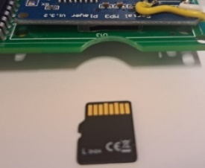
SONGS ORDER. (Re)loading songs, playing more than selectable, and making listing:
The MP3 (or WAV, WMA) files are stored on a micro-SD card. Ensure the card is clicked in. The microSD card MUST first be formatted as FAT32 (max 16GB as some 32GB cards cannot be read).
There are 3 different selection modes. Versions up to SW V14 only have FilePlay (default).
* SelectMode = FilePlay (Default)
Place selectable files in the card root folder (filename is not important/relevant). Note when copying files from the PC onto the SD card, Windows hustles the order that then does not match the file/selections. On Apple-Mac, specifically select the order you want (e.g., alphabetical). To get the ordering right is as follows:
Format the SD card; Copy files from computer to SD, one at a time starting with the first one; Wait until each file is copied, then copy the next (every time just one at a time).
This way, windows will not change the order as every file can only be added and has a later timestamp than the previous one.
* SelectMode = MP3NumberPlay (SW V14 and up)
Files must be placed in folder /MP3/ and numbered using 4 digits 0001.mp3, 0002.mp3, 0003.mp3 etc. (or, such a four-digit number and space followed by a filename ‘0001 my way.mp3’ ‘ 0002 blue moon.mp3’ etc.). This mode allows ordering by filename numbering and is easier for individual replacements.
* SelectMode = AlbumFolderPlay (SW V14 and up)
A complete album/LP can be played with one selection. Cancel plays next album song. A set of files (album songs) should be placed in folders /01/, /02/, /03/, etc. /99/ is for extra songs 001.mp3, 002.mp3. To list the order of the songs on the music SD, use DOS command (run CMD after clicking search icon and CD to your SD card): then DIR /B /A:-D *.MP3 > SONGS.TXT. This will create a file that you can read and use for song titles
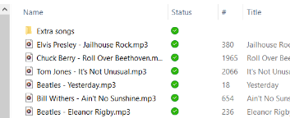
The WallboxPlayer can play songs that go beyond the selectable numbers through AutoPlay (random). Simply create an extra folder (after having put the selectable songs on the music SD) e.g., /Extra songs/ and simply fill it with the songs you want to hear in random play mode. In below, the folder “Extra songs” contains songs (see picture).

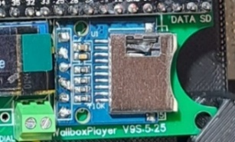
WallboxPlayers with data SD slot option: Configurations that have a data SD card (right of the display, see picture), enable creation and use of song labels and displays song filenames. For labels and the display, song information from the MP3-ID3 tags (software >V14.5) are retrieved, or otherwise filename (“Artist - Song”), will be generated. Once this is done, the data SD card can be removed (returned into the player slot) and songtitles are remembered.
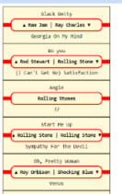
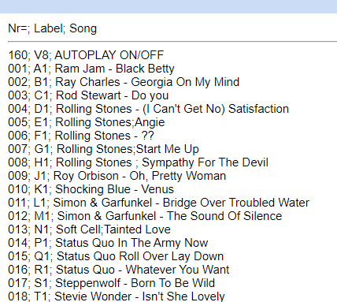
- To generate these files, insert the MUSIC SD (with MP3’s) in the data SD slot and (re)start the device. Files SONGS.TXT, PRINT.HTML and LABELS.HTML are generated in folder /labels/. These can be used to help make song listings and labels (open with computer). Files can be edited/corrected by clicking and editing before printing. After generating files, insert music SD into the blue player SD slot again.
- To generate a custom listing or for album mode play, the file SONGS.TXT (with a song- or album-name on each line, sequential) on the data SD card in /labels/ (/labels/SONGS.TXT) will determine the labels shown on the display.

Troubleshooting
If the number selected by the MP3 player is higher than selected with the buttons, not enough pulses are received. Check if the rotor contacts are clean. You can try to adjust the small potentiometer on the board and turn more to the left or right, but this should not be needed.

Joop van den Heuvel
Sint-Oedenrode, The Netherlands
www.wallboxplayer.com
jhmheuvel1@gmail.com and Joopheuvel on Jukebox Addicts Board

