WallboxPlayer – Installation (Generic/Other)
www.wallboxplayer.com
Sep 2025
The WallboxPlayer is a device that turns your wallbox into a music player. This manual provides basic instructions on how to connect/install a WallboxPlayer and operate the WallboxPlayer.

General Description
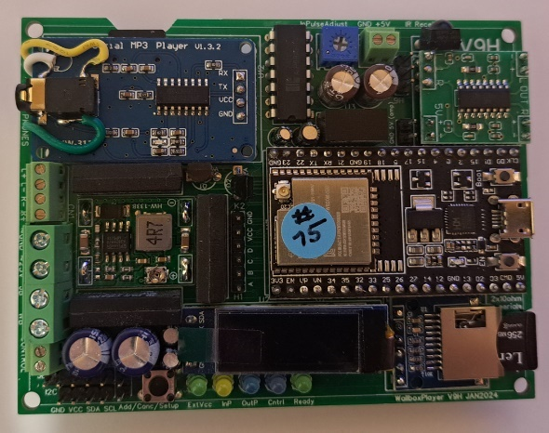
The WallboxPlayer supports a range of pulse-controlled jukeboxes. Power to the player is provided from the wallbox, reducing the need for an extra power supply. Music is stored on a microSD card and can be filled matching the wallbox titles. The on-board player accepts a user-filled microSD card. It has a jack plug for headphones or external audio. The board has an optional data microSD-slot for supporting functions. There are buttons for HW reset on the microprocessor and ‘select’ to do the setup, cancel, or add a play. LEDs indicate pulses coming in or going out and an optional credit pulse being made. The board features header connectors for an external 16x2 I2C LCD display. All settings are done in the setup through software and stored. The board has one trimmer to tune the sensitivity/speed of the incoming pulse signal. The board is powered through the external 24VAC and converts this to 5V through the on-board voltage converter. The board is 7.5 cm x 9 cm and can be mounted in popular wallboxes, or outside in separate housing.
WallboxPlayer with top cover
The 24VAC power from the wallbox is used, either through widely available 24VAC/AC, alternating current output, (48VA; 2A) transformer or adapter.
The music MP3/WAV SD card slot can be found on the top left under the music player. The contacts should be on your side and visible before inserting. The music files are stored on a micro-SD card. Ensure the card is clicked in. The microSD card must be formatted as FAT32 (max 16GB).
Speaker output is via the (optional) onboard amplifier, two speakers (max “2*3W”, at least 8ohm) can be connected using short cables. These speakers can be within the wallbox or external. The speaker output is via the connector labeled SpL+ SpL-, SpR+ and SpR-. Note the difference between wiring two separate speakers or a 3-wire consolette (see further below in this document).
LEDs onboard are used to display status:
- ExtVcc24V [green] Lights when external 24V is connected (converted to 5V), supplying the board.
- InP [yellow] – lights up when a wallbox pulse is detected.
- Cntrl [blue] – indicates second relay on/off.
- Ready [green] – shows that system is listening/ready to accept inputs (from wallbox or app).
The music player mounted on the board has a red light that lights when the player is ready and blinks when playing a song.
Adjustments are not required. In case of issues, the (blue or small smd, depending on board version) potentiometer can be used to tune the sensitivity of the input pulse from the wallbox, detected by the system. It allows for either slower turning motors or 60Hz to work properly.

Board and connections:
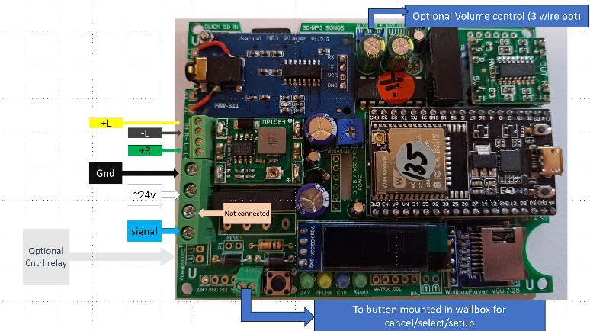
Connectors on the WallboxPlayer board:

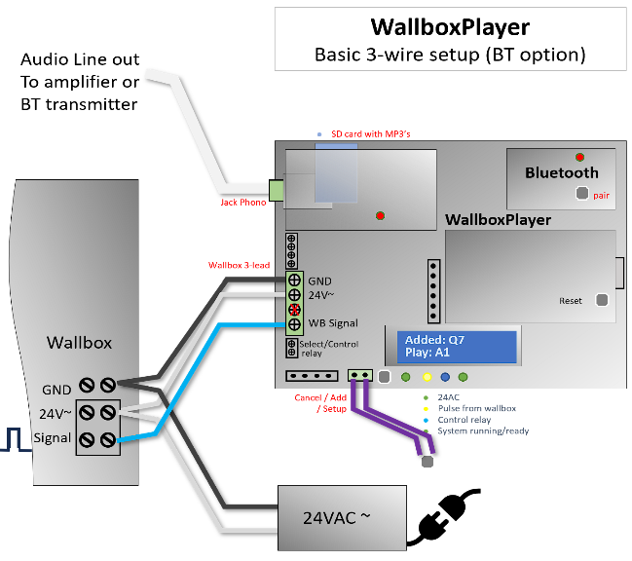
Overview of wiring to wallbox - Make connections depending on configuration/version:

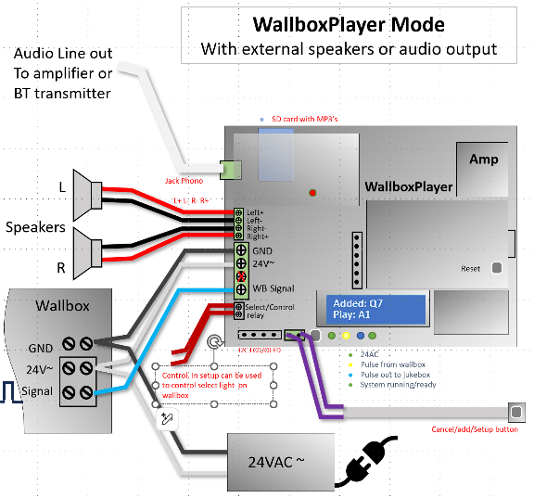
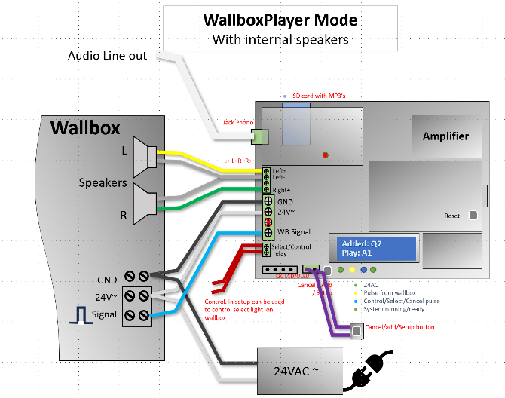

Installation and setup:

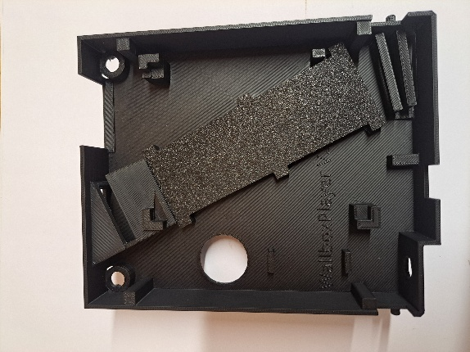
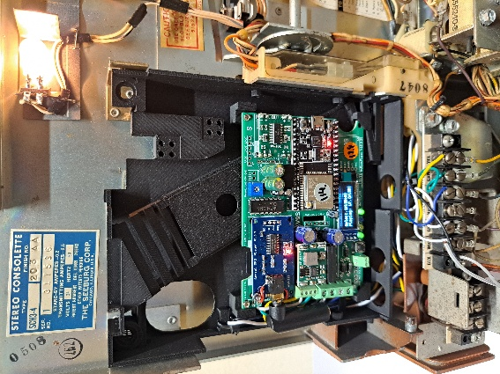
The universal coin unit replacement housing can be used to mount the board (fits most wallboxes). Remove any pins that are not needed. With care, the output of the coin slide can be tilted to front or back to hit the right flipper.

In the pictures below, wires go to the large green 4p screw header on the WallboxPlayer.

Green connector
Com / common > “~GND”
24VAC / 2%VAC > “~ 24VAC”
Signal > “WBsignal”

AMI:
AMI W40, W80, W120:
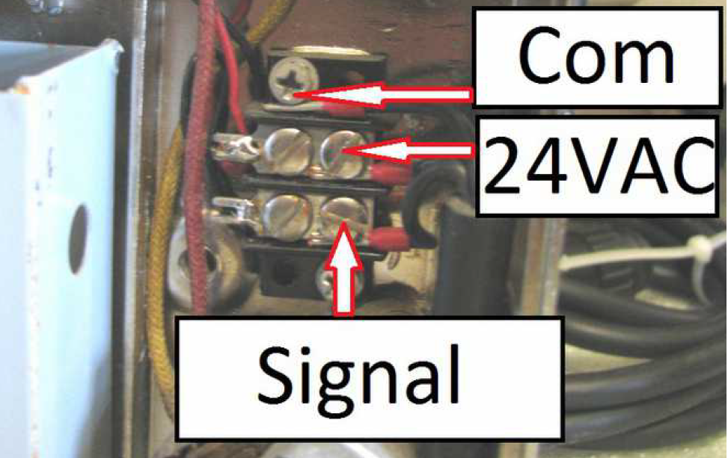
AMI W120 Freeplay:
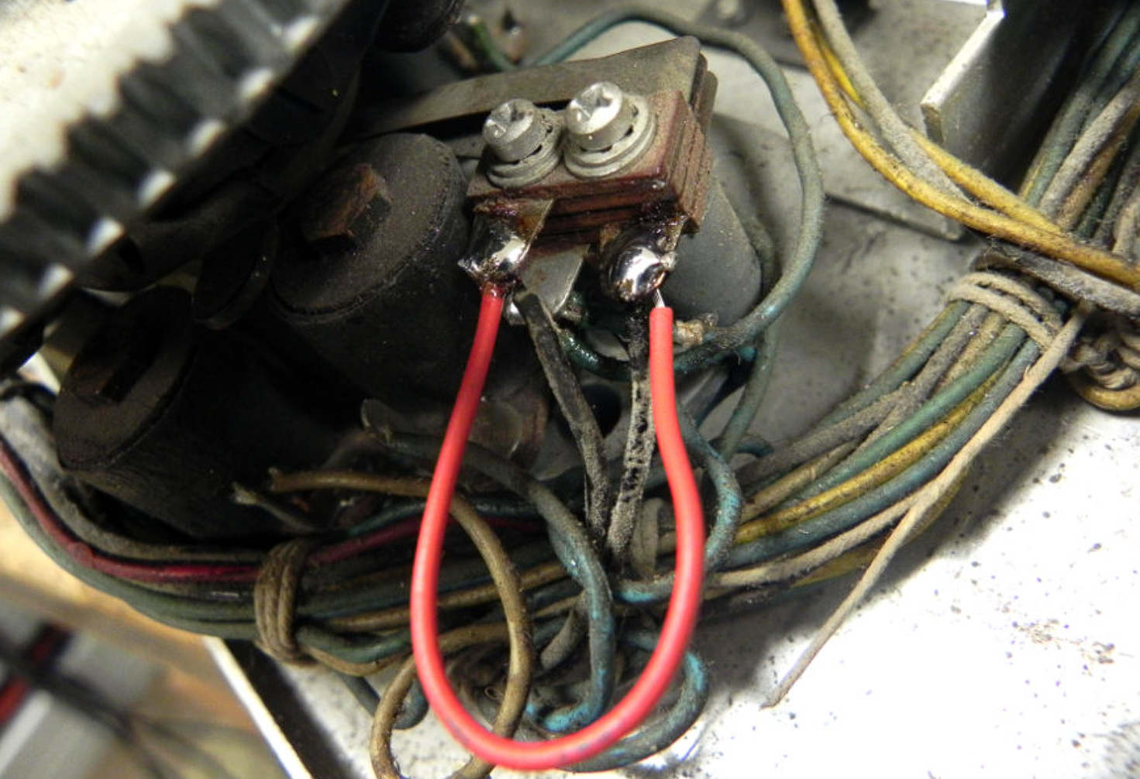
AMI WQ200 (200 selections):
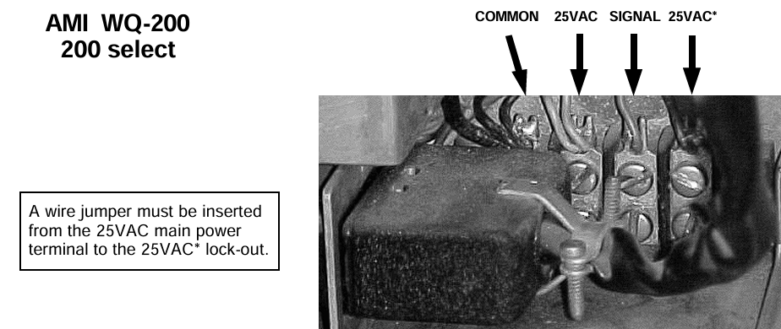
ROWE-AMI WRA-WRC (200 selections):
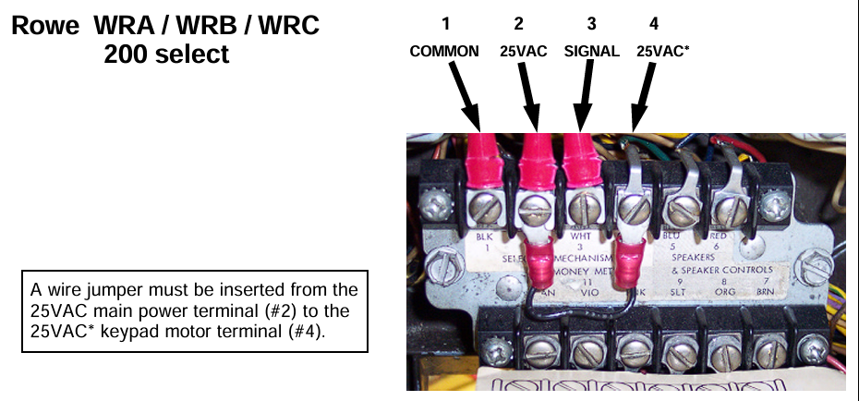

ROCK-OLA
Rock-Ola 500:
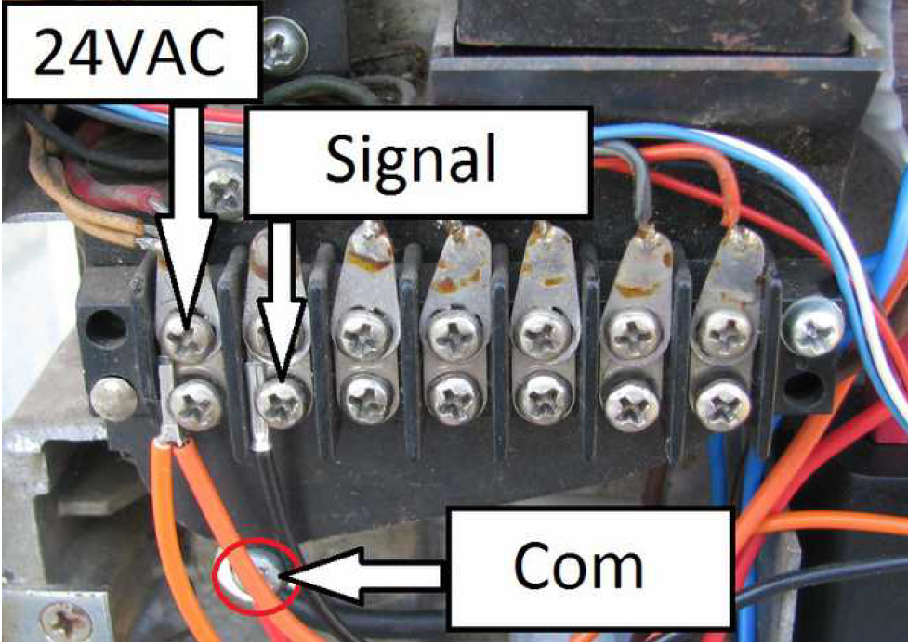
Rock-Ola 1555(200)/1558(160):
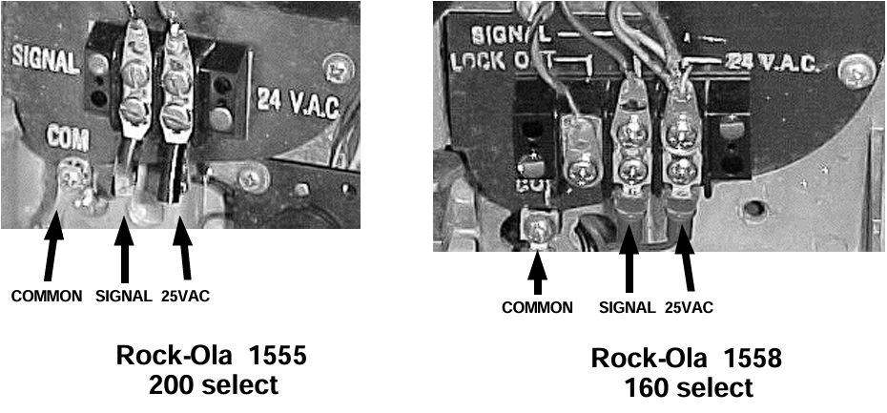
Rock-Ola 500 (160):
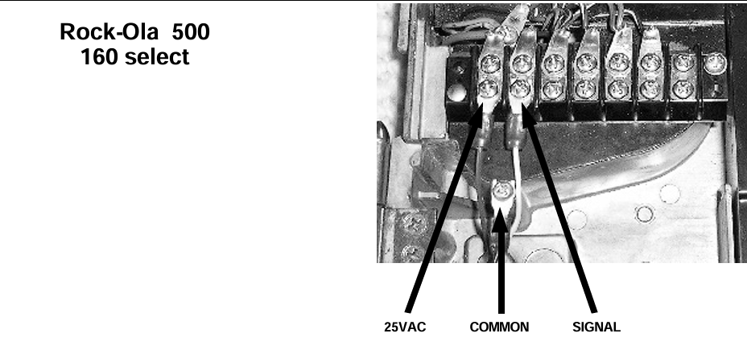
Rock-Ola 503/504 OR ROWEAMI-WRA
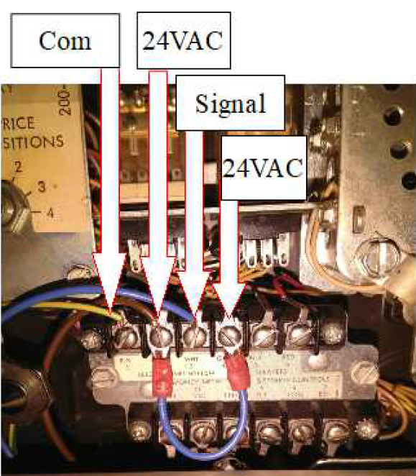

Rock-Ola 507(160):
Cut red wire to subtract solenoid for freeplay
Make connections as indicated

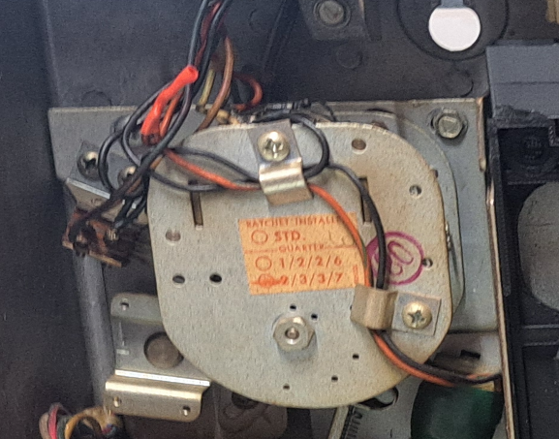
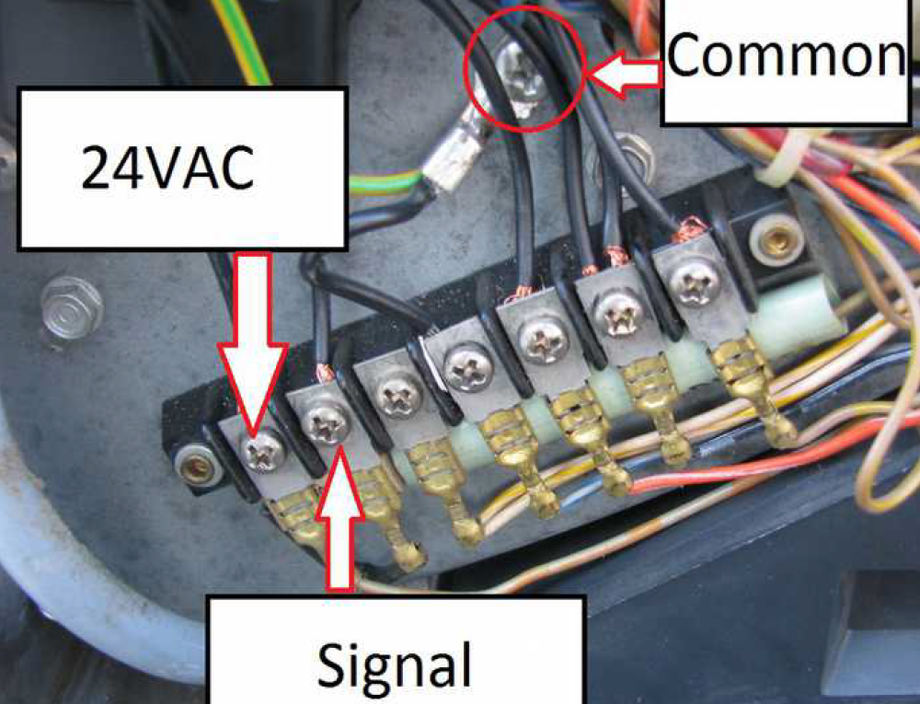
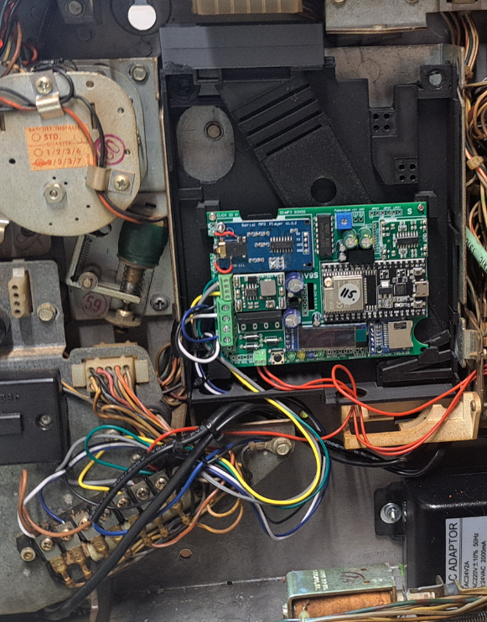
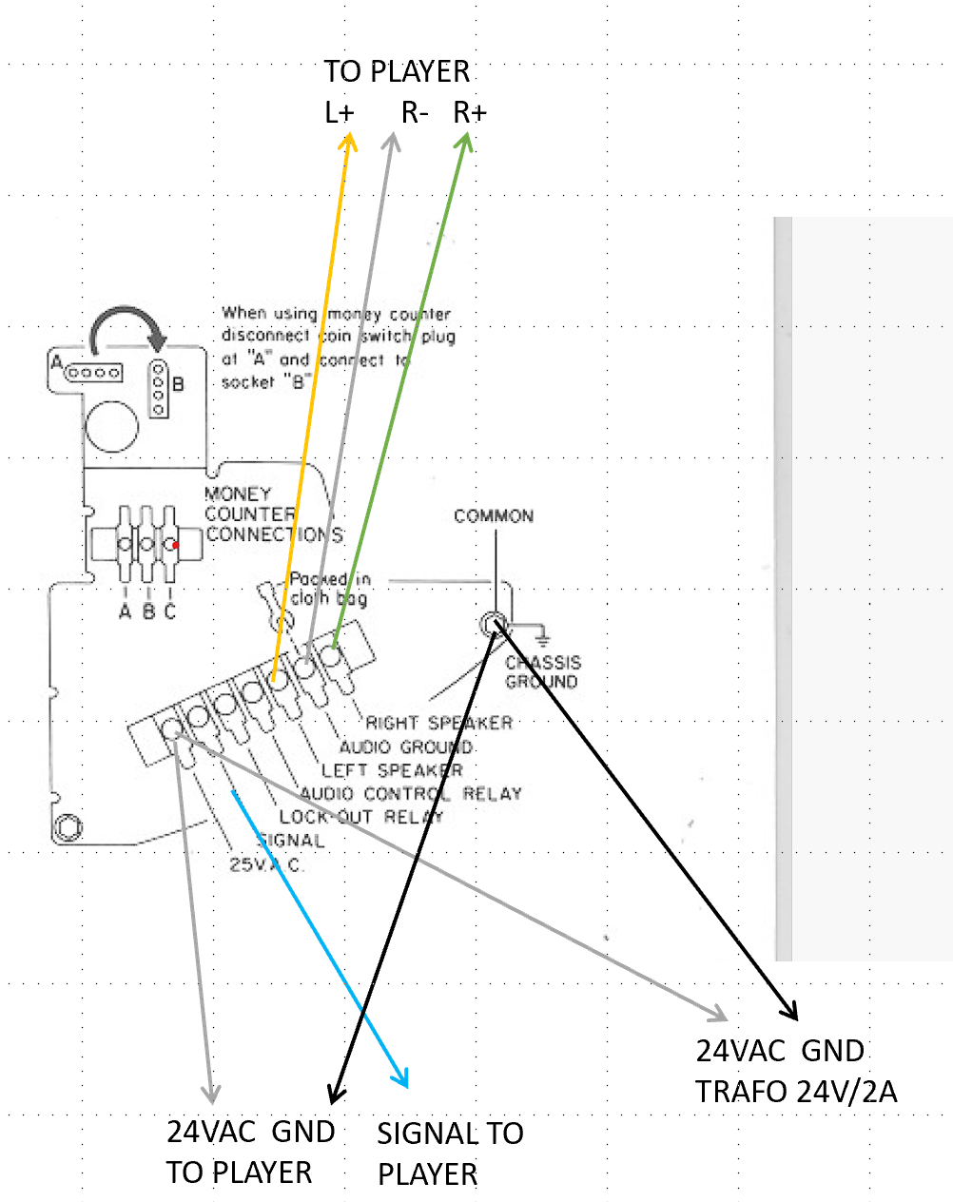

SEEBURG
Seeburg 3W1/100:
3 wire connections and 3W1 Freeplay (red connection wire).
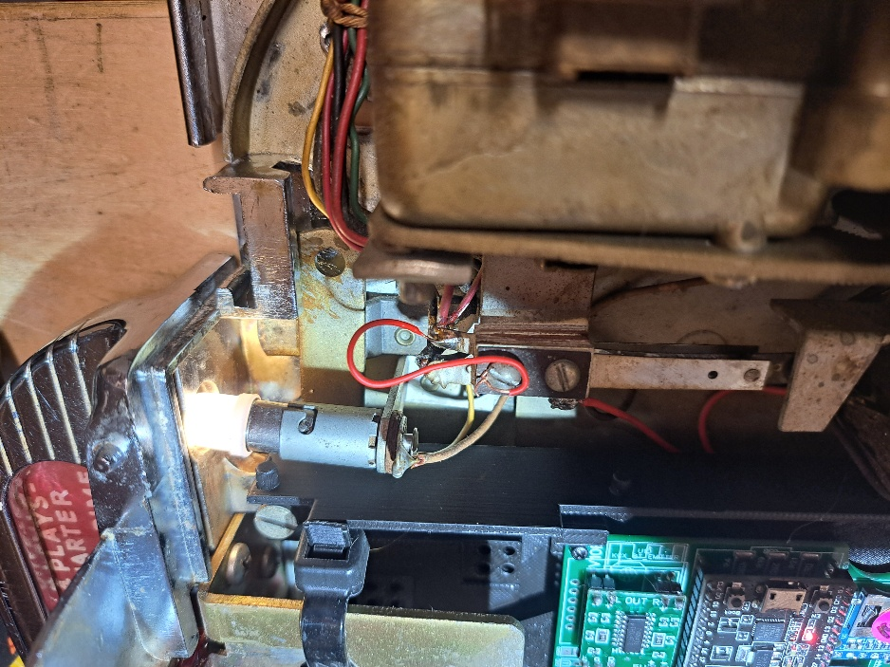
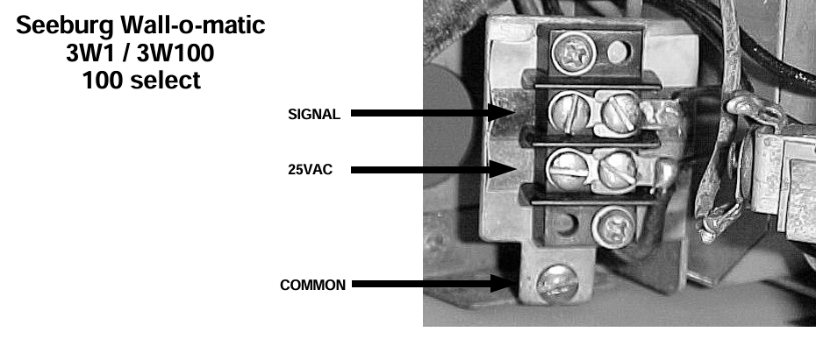

Seeburg 3WA:
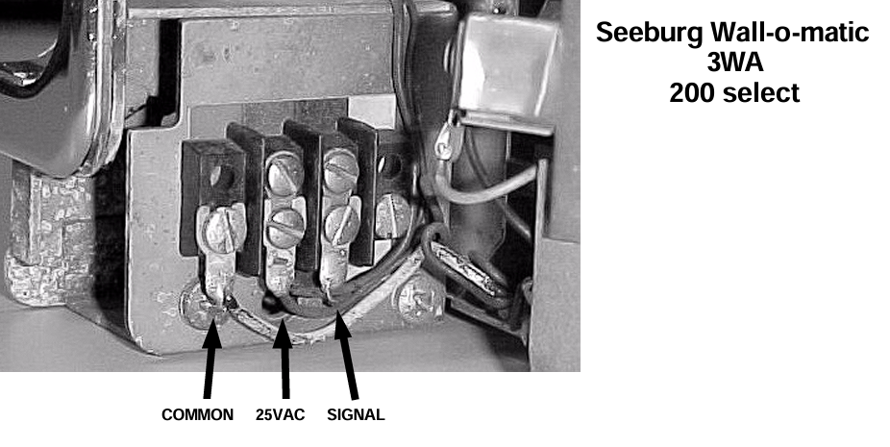
Seeburg SC1-SCH4:
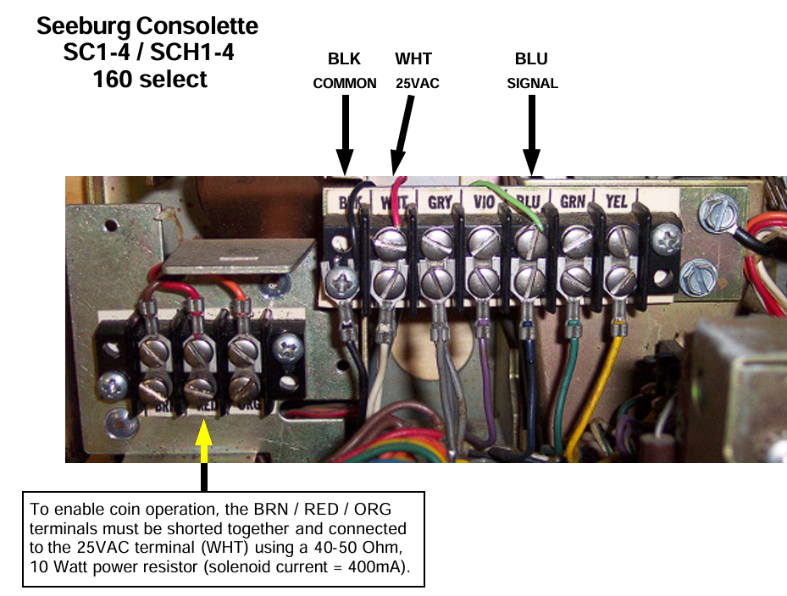
Seeburg 3W2-L65
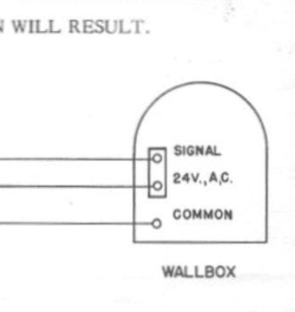
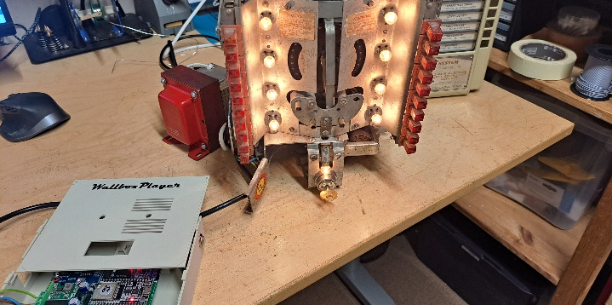
For the 3-wire L65 (this is the version with a rotor and NO tubes): simply connect the 3 wires from the WallboxPlayer (24V, GND=common and Signal) to the wallbox (see basic 3-wire setup on page 2).

UNITED
UNITED UWB1 (24V, GND, SIGNAL):
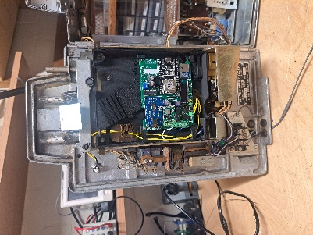

WURLITZER
Wurlitzer 5220/5225:
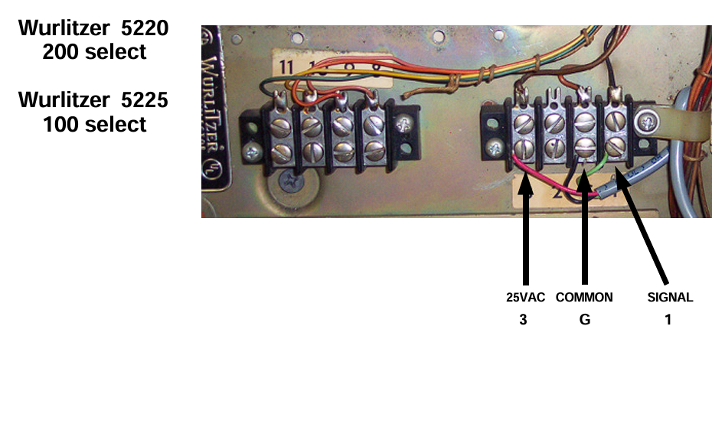
Wurlitzer 5207 (104):
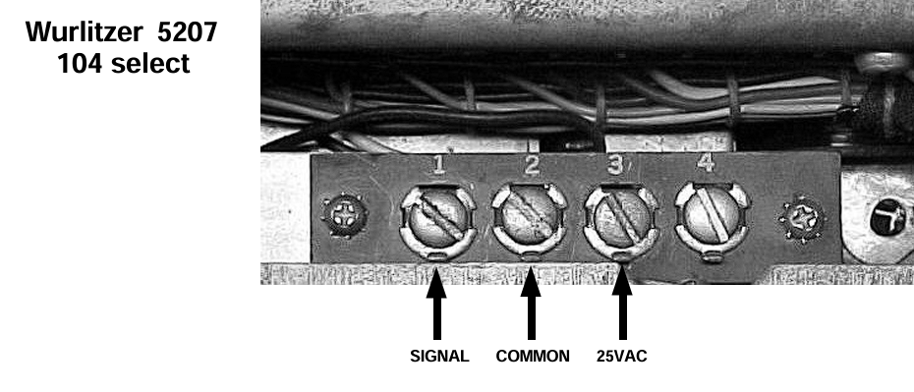
Wurlitzer 5250 (200):
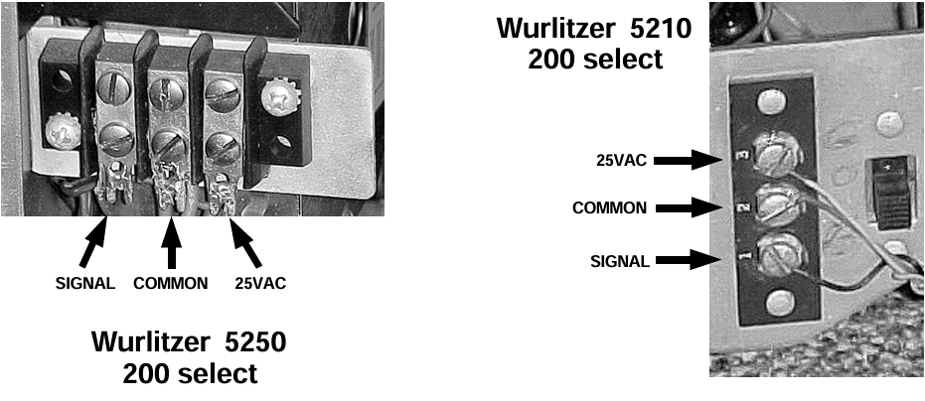
Wurlitzer 3020 (24): 1=signal 2=common/gnd 3=24-25VAC
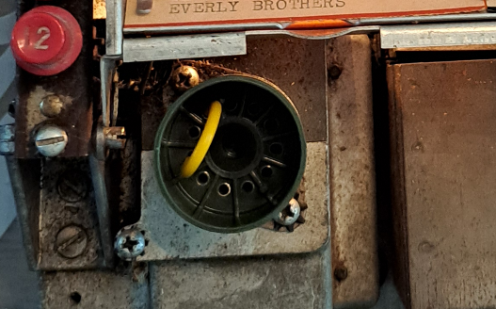
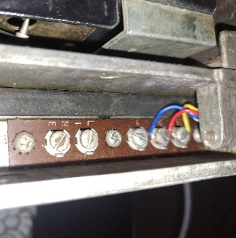
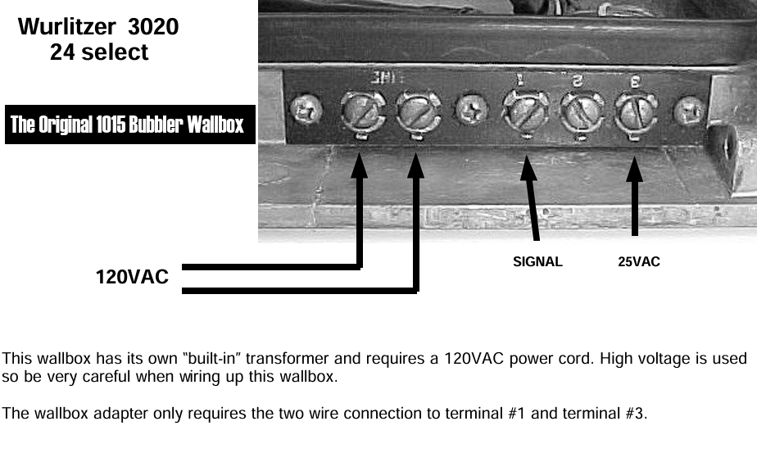

Wurlitzer FW160:
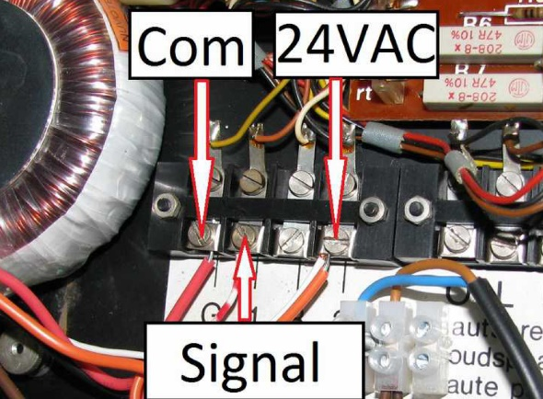

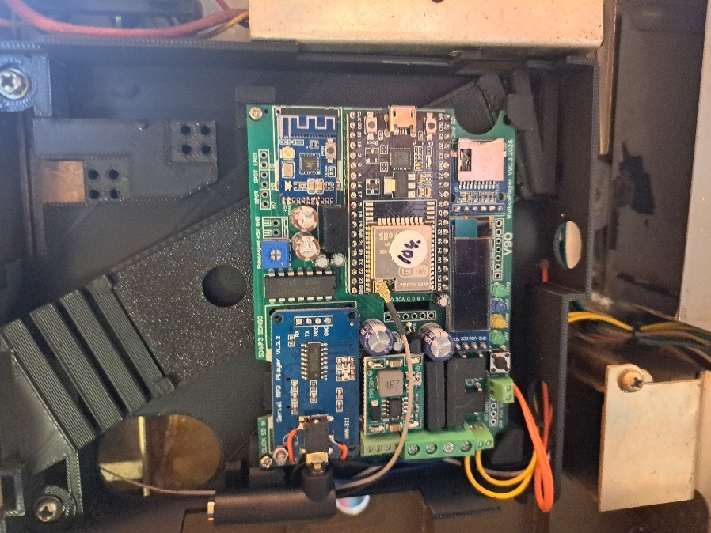
Other connections to WallboxPlayer

- Connect the select/cancel/setup button (on the board next to the button) – right in picture. This button will allow cancel and adding random songs.
- Optionally, if the select lightbulb is to be enabled, cut one of the wires and prepare to connect to the relay. Connect the relay to enable the Wallbox “Make selection” lightbulb (bottom 2p small screw connector) top-left in picture. The optional control relay can be used to enable the lamp that lights up to select a song once the player is ready.

Important: Connecting the speakers in a wallbox (or a set of two speakers)
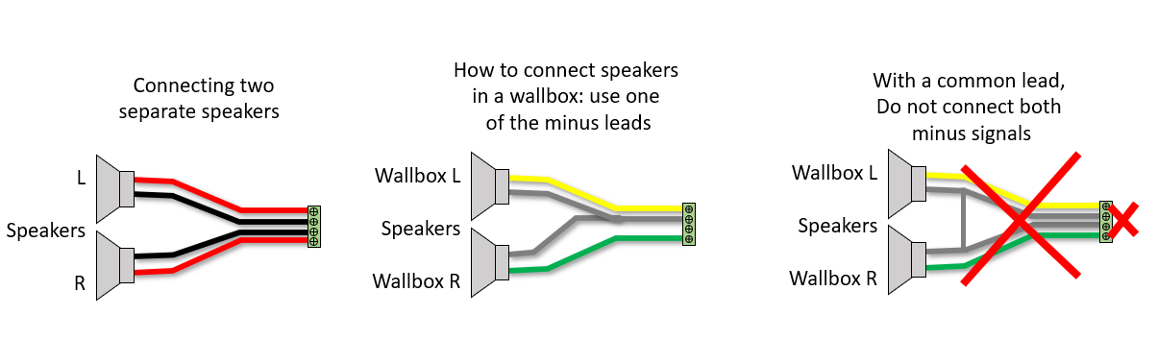

Important: making a connection between one of the four wires and the ground of the wallbox will result in (irreparable) damage of the onboard amplifier.

Connecting the 24V AC/AC transformer and powering up
- Connect the 24VAC/AC (2A) transformer to the Wallbox.
- After powering up, the WallboxPlayer will also power up, and the display will show relevant information on status and number of songs and is ready to select a song.
- Press the “Select/Cancel/Setup” button on the board to test if song will start. Press again to cancel.
- Make selection on the Wallbox with the buttons. If blue wire is correctly connected, the yellow lamp will flash during rotor movement. Song will start and number played will be shown.
After connections have been made, powering up should show screen startup messages and number of music files on card. After a few seconds, the system will show the green status light and be available for selections and will display it is ready to select a song. If the control relay is set up to enable the lightbulb, the blue led will also be on. When during startup, the music (MP3/WAV) files cannot be read, the status LED will blink twice, and the red music-player LED will not be on.

Pairing Bluetooth (optional)
- When paired and connected, the red Bluetooth LED blinks twice at ~5 sec interval.
- When idle and unpaired the red LED flashes slowly (~1sec interval).
- Short press the button for unpairing.
- To pair with a Bluetooth device, ensure it is not paired (with other device) and put the Bluetooth speaker in pairing mode and press (2sec) the pair button, the red LED will blink slowly (at ~2sec interval) and start pairing.
- For more information look at the KCX BT module documentation.

Setup

The onboard ‘select’ button perform setup serves two functions, its primary function with a short press, is to CANCEL the currently playing song or ADD a song when nothing is playing. For the latest releases, a long press (~2 seconds) will START and STOP AutoPlay. The secondary function of this button is used within the setup menu which follows. The setup menu is accessed by pressing the ‘select’ button for at least 5 seconds. After the instruction, which will be displayed for a few seconds, subsequent settings will be shown to be modified. Pressing the button will change the value of the item, waiting will show the next configuration item.
The setup menu allows you to configure the following settings:
- Tools: This menu choice will allow system updates, reset values, restart and a measure/listen utility mode. “RESTART” will restart the device. Note that the music player will keep playing until early in the startup process. Selecting “DEFAULTS” will set values of settings back to factory defaults. Choices: NO, RESTART, DEFAULTS, UPDATEMODE, CLEARFAV, LISTEN, …
- Wallbox_In: This will configure what input signal is detected by the board, the type of wallbox the board is connected to. Compatible choices: NONE, MP3, Sb_3W1, Sb_3W100, Sb_3W160, Sb_3WA, Sb_SC1, Seeburg_DEC, Seeb_DEC-direct, Ami_W40, Ami_W80, Ami_W120, Ami_W200, Roc_1544, Roc_1555, Roc_1558, Wur_5207, Wur_5210, Wur_5220, Wur_5225, Wur_5250, … and more
- Jukebox_Out or Player_out: for WallboxPlayer mode and audio output, this must be MP3. For other selections, it will send out a pulse to a connected jukebox. If output is Spotify, and settings are correctly entered in the config, songs will be played on the linked Spotify account/device.
- AutoPlay: This value sets the time in seconds until a random song is added to the queue. Selecting “0” will disable this function. Setting it to “60” will add song after one minute of idle time. Choices: 0, 15, 60, 300, 3600.
- Volume: This will determine the output volume of the MP3 player (jack output and speakers). It can be adjusted from 0 to 24. Choices: (0…24). Suggested is “20”.
- Equalizer: This will select one of the available equalizers (jack output and speakers). Choices: FLAT, POP, ROCK, CLASSIC, BASS. Suggested are Pop or Bass. Newer releases have boost-variations (+20%).
- AutoPlay_number: Selecting this number with the buttons, (1=A1, 160=V8), will select autoplay and play random songs until selected again. (0, 1 … 159, 160, 200 (default is 0). Suggested 0 (off) or number 1.
- Control_mode: This determines the function of the additional on-board relay: NONE, JBCANCEL, WBCOIN, WBCREDIT, SELECT, ON-OFF (default is ON-OFF). The “Select mode” can be used to enable the “Make selection” lightbulb in the wallbox. WBCOIN is to generate a coin drop with the relay after a selection is made.

OPERATION:
The WallboxPlayer in the wallbox (or an enclosure) has the following functions that are available
- Songs can be selected on the wallbox, play will start after selection or when a song is playing, song will be added to the queue
- If a song is playing, the ‘select’ button will cancel the song (and play next in queue)
- If no song is playing, pressing the ‘select’ button will add a random song to the queue
- After choosing the AutoPlay number/selection (as set in the setup, 1,2,159,160), random songs will automatically be added and played (even song files on the SD beyond the selection limit of 160 or 200 – see instructions further below for how to do this.), select AutoPlay number again to switch off the function

(Re)loading songs, playing more than 160/200 and making listing
The music files are stored on a micro-SD card. Ensure the card is clicked in. The microSD card must be formatted as FAT32 (max 32GB). The best place for the music files is in the root folder of the card. When copying files from the PC onto the SD card, Windows will hustle the order that then does not match the file/selections. A foolproof way to get the numbering and order right is as follows:
- Format the SD card
- Copy files from computer to SD with drag and drop, one at a time starting with the first one
- Wait until each file is copied, then copy the next (every time just one at a time)
This way, windows will not change the order as every file can only be added and has a later timestamp than the previous one.
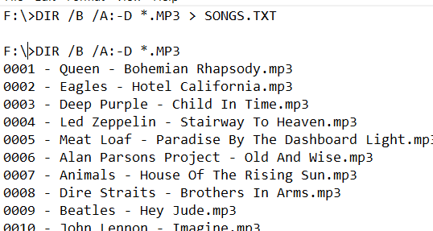
The best way to get a matching listing of the order of the songs on the SD, use Windows CMD command:
DIR /B /A:-D *.MP3 > SONGS.TXT
This will create a file that you can read and use for song titles.

Some WallboxPlayer configurations have a data (second) SD card slot; this will store song titles that are displayed on the display (and web browser). A file /LABELS/SONGS.TXT (edit with NOTEPAD!) with titles for each song will then be used.

The WallboxPlayer will also play songs that go beyond the selectable numbers (160/200). This is great for random play and hearing (random/surprise) songs other than the ones on the labels. For this, the best way is to create an extra folder (after having put the 160/200 songs on the SD) and simply fill it with the songs you want to hear in random play mode. In below, the folder “extra songs” contains (up to ~800) songs.

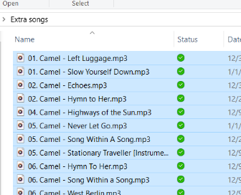
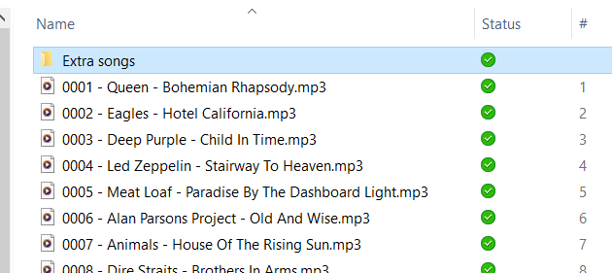

Selection conversion table:
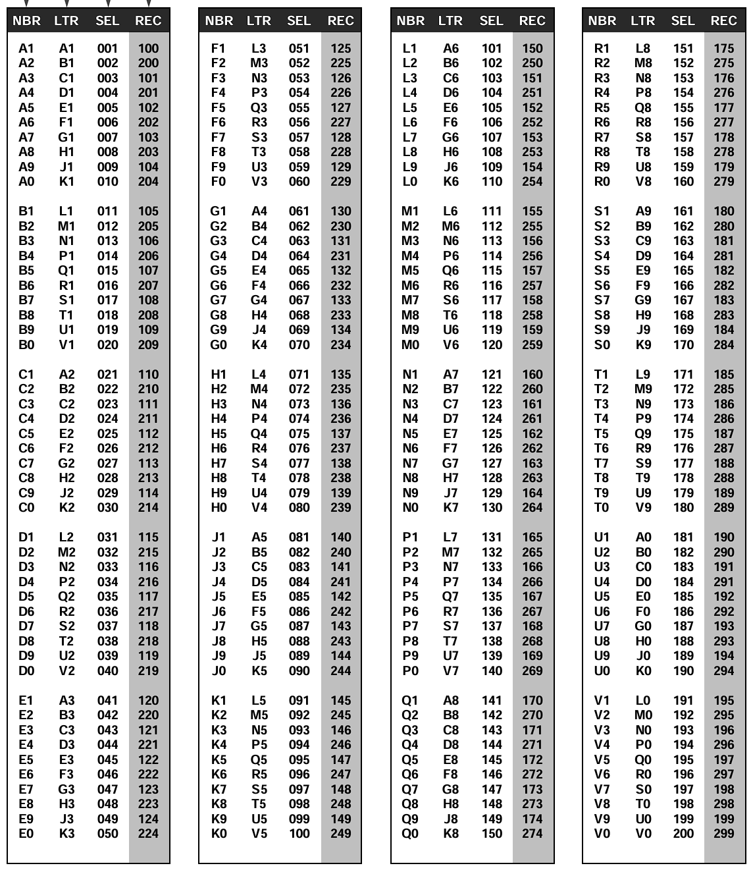

Troubleshooting
If for a consolette, the number selected by the MP3 player is higher than selected with the buttons, not enough pulses are received. Check if the rotor contacts are clean. You can try to adjust the blue potentiometer on the board and turn more to the left or right, but this should not be needed.

Please contact me in case of questions or inquiries or items not described here.

NOTES FOR ROCK-OLA 503/504
- Take care opening as the two hinges come loose easily!
- The Wallbox must be standing up for normal operation (not lying down)
- If front and back side have been disconnected, ensure the two connectors are well connected again
- To change titles, push the black part above the title strip holder up. Take care. When inserting click it in.
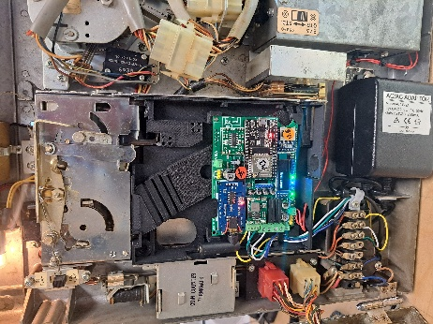
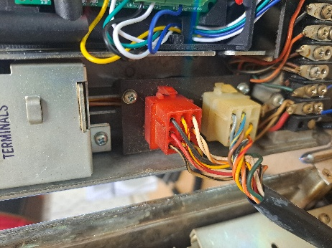
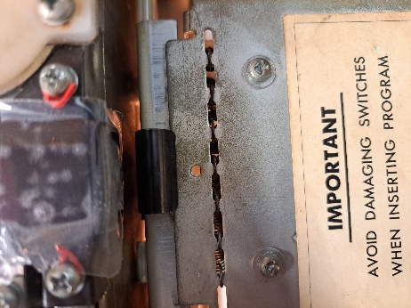
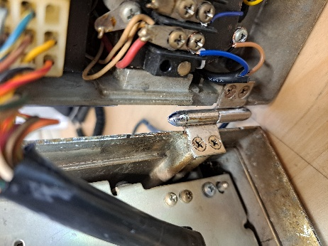
www.wallboxplayer.com
jhmheuvel1@gmail.com and Joopheuvel on Jukebox Addicts Board

